**Next.js Tutorial**

## Contents

Introduction 3

Setup 4

* File Structure 4
* Flow of control 5

Routing 6

* Nested routes 7
* Dynamic routes 8
* Nested Dynamic routes 9
* Catch All Routes 10
* Link Component Navigation 11
* Navigating Programmatically 13
* Custom 404 page 14

### Pre-rendering and Data Fetching 15

### What is it and why? 15

### Static Generation 16

### getStaticProps 17

* + - Inspecting Static Generation Builds 20
    - Running Static Generation Builds 21
    - Master-Detail Pattern 23
    - getStaticPaths 24
    - fallback key 27
    - Static Generation & Issues 30
    - Incremental Static Generation (ISR) 31

first look at json.server

<https://www.npmjs.com/package/json-server> 31

* + - Stale while revalidate 33

### Server-Side Rendering (SSR) 35

### getServerSideProps 36

* + - SSR with Dynamic Parameters 37
    - getServerSideProps context 38

### Client-Side Data Fetching 41

* + - SWR for Client-Side Data Fetching 43
    - Pre-rendering + Client Side Data Fetching 46
* Pre-rendering and Data Fetching summary 47

API Routes

* Introduction 48
* GET requests 49
* POST requests 51
* Dynamic API routes 52
* DELETE requests 53
* PUSH requests…?
* Catch all API routes 54

Styling in Next.js

* + Global Styles 57
  + Component Styles 58
  + SASS or SCSS 58
  + CSS-in-JS solution 58

Miscellaneous Section

* App Layout 60
* Head Component 61
* Image Component 62
* Absolute Imports and Module Paths 64
* Static HTML Export 65
* TS Support 65
* Preview Mode 66
* Redirects 66
* Environment Variables 67

### Authentication

* Authentication in Next.js 68
* Next-Auth and GitHub sign-in 68
* Client-Side Authentication 71
  + Securing pages client-side 74
  + NextAuth Provider 78
* Server-Side Authentication 80
  + Securing Pages Server-Side 81
* Connecting to a Database 83
* Callbacks 85

## Deploying a Next.js application to Vercel 87

### **Introduction**



What is Next.js

-The React Framework is for building production-ready applications

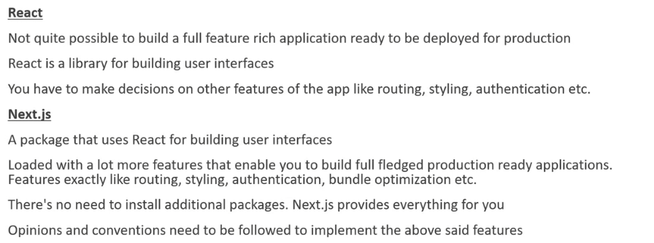

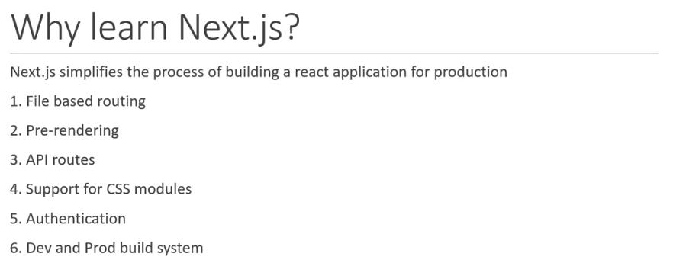

### **Setup**

Install/update node.js

<https://nodejs.org/en/>

In VS code, run the following command to create a next application:

npx create-next-app ‘app name here’

CD to the newly created directory with the application name and start a development server with ‘yarn dev’.

**File Structure**

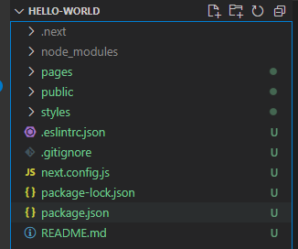

Here is our new project. Lets look at the files.

**package.json**

This file contains the dependencies and scripts required for the project. As new dependencies are added through yarn or npm, they will be added to the lists here. New scripts can be created and placed in this file as well.

**yarn.lock or package-lock.json**

Depending on whether you have used yarn or npm as a package manager, this file essentially ensures consistent installation of dependencies and does not need to be edited - don’t worry about this file.

**.gitignore**

This is a file relating to version control and we know what it does

**README.md**

In this case this readme gives information about next.js, its various uses etc.

**next.config.js**

This is the next.js configuration file which only has one module active within it when the project is created - ‘reactStrictMode’ which is set to true. This is a development mode only feature which is for highlighting potential problems within an application. It helps to identify unsafe lifecycles, legacy API usage and a number of other features.

**.eslintrc.json**

This is the config file for eslint. The code within this file, when it is initially generated, relate to a bunch of rules put together by the next.js development team.

**.next folder**

This is the folder that is generated when we run the dev or build scripts. 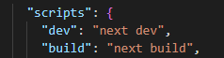

It is from this folder that our next.js application is ‘served’.

**node_modules folder**

This is the folder in which all the dependencies are installed. It is generated when you run the command yarn/npm install. In our case, it was generated when the yarn dev script was executed which installs all the dependencies required if they’re not present.

**styles folder**

This folder contains some styles for our project. It is possible to define styles in a few other folders within the project so this folder does not have real significance. CSS basically can go here.

**public folder**

This folder holds all the public resources for our application. Images, svgs, icons etc. This folder is different to the similar one created in a React application. In that scenario this folder would contain an index.js file which would contain the single html page for the react application. There are no files of this type in this file in next.js. This folder is for public resources.

**pages folder**

This folder is responsible for the entire routing feature in a next.js application. This will be covered in detail in this tutorial.

**index.js**

This file is the one that is served in the browser when we visit the local host.

**_app.js**

This is where we can define the layout of our application

**api folder**

This is where we can create apis for our application.

**Flow of control**

When you type yarn dev or npm run dev the execution goes through the following steps.

1. package.json where the script is recognised.
2. _app.js

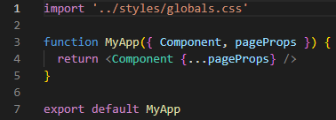

This file contains the ‘MyApp’ component. This will automatically receive the Component and PageProps as props which are then returned as part of the jsx.

Index.js



When running the application on the development server, the component prop will refer to the component defined in the index.js file which in our case is the Home component.

### **Routing**

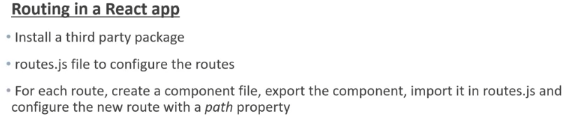

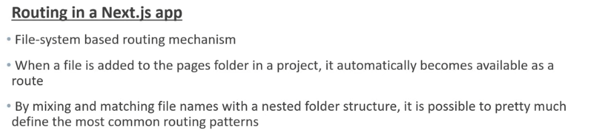

In this tutorial we’ll focus JUST on the filing system and how the routing works. So delete the api folder and the index.js file both of which are in the pages folder. Leave public and styles folders as they are not relevant.

As mentioned in the introduction, next.js has a file-system based router. The convention is that when a file is added to the pages dir/ it is automatically available as a rout.

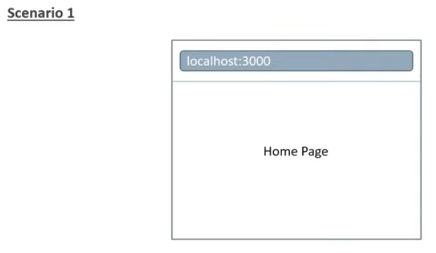

With page-based routing, lets add a rout that needs to be rendered when the user visits our website (localhost:3000). To achieve this, we create a file called index.js in the pages folder. Create a function in this component and give the return statement a h1 tag with ‘Home page’. Then run yarn dev and this should load a page with the words ‘Home Page’ displayed.

**The index.js file located in your pages folder will map to the root of your domain.**

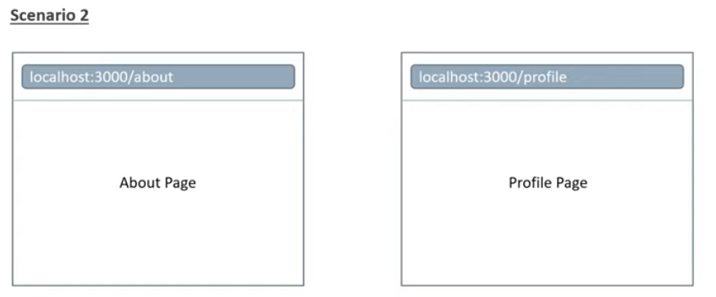

Now lets add the above routs for our domain. This is a simple case of creating .js files for each with a simple function exporting.

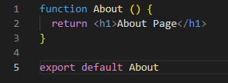 This is an example.

**Pages are associated with a rout based on their file name. E.g. about.js maps to localhost:3000/about**

**Nested Routes**

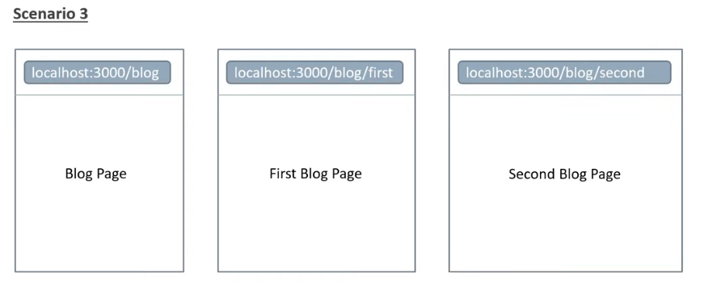

Here we have a scenario where we want access to a blog page but then access the first blog or second blog from there.

Part 1 of this would be completed the same way as the example in scenario 2. How to implement the nested routes for first and second blog. Very simple. This can be easily achieved in next.js using nested folders in the file structure. So we create a blog FOLDER and put a first and second.js file in there to create the nested components. Now we have a blog folder with two files in it but the original blog.js file is still in the pages folder. It would be nice to be able to put all the files relating to one domain area together right? This is very simple to do. We just move the blog.js file INTO the blog folder and rename it as index.js. **An index.js file inside a folder, nested within the pages folder, will map to the rout of the folder name as a rout.**

**Dynamic Routes**

Here we will build a product and listing page and then an individual page:

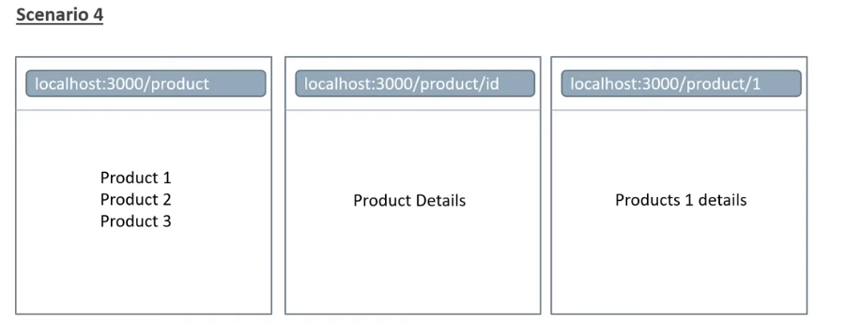

The first part here is achieved in much the same way as scenario 2. As you can see, using the scenario 3 process would require creating an individual .js file for each product. Obviously this is not plausible for a store with thousands of products. The correct solution is to use DYNAMIC ROUTE SEGMENTS. In next.js you need to add square brackets to a file name to create a nested dynamic route. Here we’ve created one called [productId].js. Pascal case is being used here. Inside this file we simply create the same function that we have done previously…

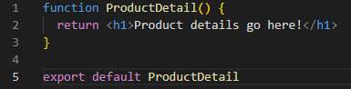

Now we can type ‘http://localhost:3000/products/2’ or even ‘http://localhost:3000/products/12430’. This is possible because next.js treats square brackets in a file name as a dynamic segment to create a dynamic route. So now we have created a dynamic route but now we need to improve the jsx. At the moment we are only displaying ‘product details go here!’ irrespective of which product we have chosen. In a typical application we would want to extract the id of a product and display something to do with that specific product on it’s corresponding page. Perhaps by retrieving information from a db by making an api call using the product id. In this simple scenario let’s just display the product ID in the browser. In order to do this we need to import a hook from the next.js package. This hook is called useRouter and returns a router object. From this object we can access the query object - router.query. The parameter we want to access is productid 'router.query.productId’. It is important to note here that productid on the query object corresponds to the dynamic segment we have specified for the file name. This needs to be the same. Now we can access the productid in the jsx.

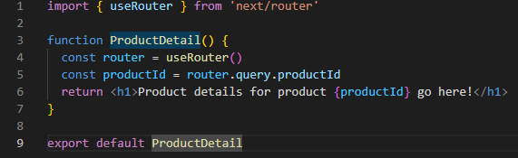

It is important to note that as part of the router.query.productId is actually a string so any word or number or combination could be placed in there. Lets add the word ‘sweater’ to the url - <http://localhost:3000/products/sweater>. As before it will load up a page with the product details of {productid} here which is ‘sweater’. If you then create a new nested route called ‘sweater’ that loads say a string ‘Loading page for sweaters’, next.js will FIRST search through the route folder for a file with that name and display that as a nested route. If it cannot find the specific file name THEN it will load the dynamic nested route instead. Cool functionality.

**Nested Dynamic Routes**

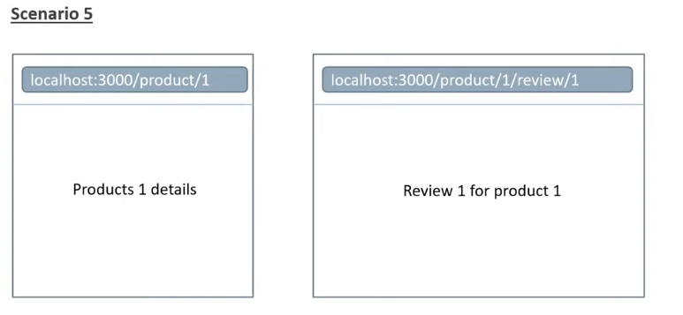

Here we will explore how to display a product by it’s ID as in the previous scenario but then display a specific review for that product. A nested folder structure is the answer here as in scenario 3. In this case though, the nested folder will have square brackets. As before, we want the productid.js functionality to be stored within this folder as with scenario 3 so we move it into there and change it’s name to index.js. Now that we have this nested folder set up (and it’s dynamic properties are still working as expected because of the inclusion of the square brackets) we can now create a new NESTED dynamic folder WITHIN this folder. This is then essentially following scenario 4. Here we do not have to put the folder ‘review’ into square brackets because it does not have any more nested dynamic routes. Were we to add another nested level, lets say [http://localhost:3000/products/2/review/21/**comments/130**](http://localhost:3000/products/2/review/21/comments/130)**,** then we would have to repeat the same process as we have done here in scenario 4 for the new nested dynamic routes.

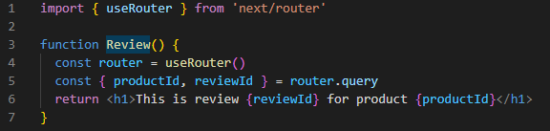

You can see here that the router.query is assigned to more than one variable so you need to use destructuring to access the different variables - see line 5.

**Catch All Routes**

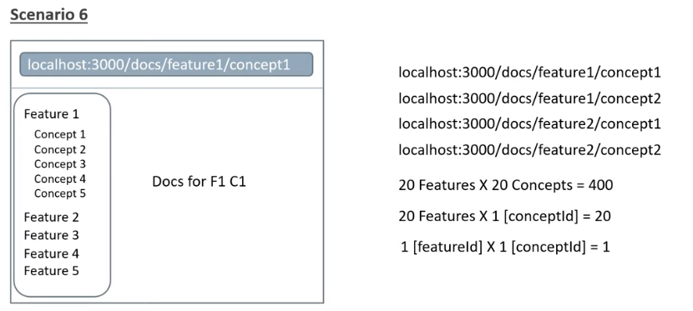

So here the example shows a webpage where there are a number of features and each feature has a number of corresponding concepts. We can see that if there are 20 features each containing 20 concepts then all of a sudden we’ve got 400 files that would be necessary to create. We’ve discovered in scenarios 4 and 5 that dynamic routing is possible so we could incorporate this to have each feature having dynamic nested concepts which would leave us needing to make 20 files. We could do one better still and have a dynamic feature and a dynamic concept which would mean only creating 1 file. In order to make this possible next.js has special file convention that is used:

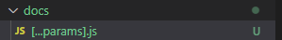

Here we see that the params file has both the square brackets denoting a dynamic structure but also the ‘…’ three dots similar to the spread operator. The name params is a convention and it refers to the parameters that are passed into this file. Within the file lets create a simple component. 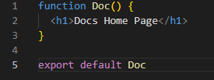

What is special about this page is that it will match any url that contains the docs segment in the path. So for example <http://localhost:3000/docs/feature1/> and <http://localhost:3000/docs/feature1/comment1> will both return the […params].js component.

<http://localhost:3000/docs/anything-you-like-after-the-word-docs>.

**This catch all route catches all the URL segments and maps them into one single file in the project.** This is useful for something like a documentation site because we want the different segments in the URL for better organisation and SEO but the layout for the document will remain the same. We’ve seen above in scenario 5 how to access multiple variables within the router.query using destructuring. The same applies here through the params keyword - it could be any word but this is the convention. In the example above where we have <http://localhost:3000/docs/features/1/comments/27> then the params constant would return an array with 4 elements: features, 1, comments, 27.

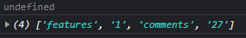

Instead of returning a string, params returns an array of strings.

It’s also worth noting that initially ‘undefined’ is returned. This is because of the prerendering feature in next.js which will be covered later in this tutorial. As a quick fix you could set the initial value of the params to an empty array to avoid a runtime error.

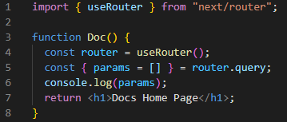

Now lets update this file to display more information relating to the parameters passed in. Here we use if statements to work through the length of the array and act according to the array length.

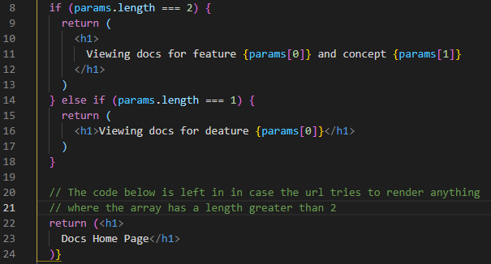

This is a simple setup and ideally you would have each if statement fetching specific documents from the db via an api.

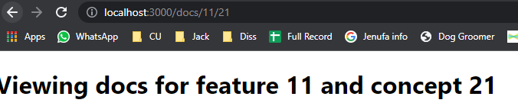

Here’s an example of the system working. Scenario 6 has been implemented now.

Another example use-case could be a property website where the user wants to view houses BUT they also only want to view the ones that are within a budget of 250k and 500k. Something like: <http://localhost:3000/propertywebsite/houses/250000/500000>. The values could easily be accessed using the params process set out in scenario 6 and then used to create an array of the houses that fall within that category.

It is also worth noting that next.js provides optional catch-all routes. Were we to type <http://localhost:3000/docs> we would currently get a 404. These optional routes allow us to deal with this and will be covered later in this tutorial. In simple terms it can be delt with by rapping the params file in a second set of square brackets.

### **Link Component Navigation**

Typically there would be a UI element the user would click in order to navigate to a different route or the user could be navigated programmatically after a specific action has completed. Lets explore this.

For the first example, using the file structure and files already created from the above tutorials relating to routes, let’s try navigating from the home page to the blog page. To do this we simply use the Link component. This is for client-side navigation. Firstly import the component in the index.js file inside pages. This is the root index file for the app. Then simply create a link tag with the href of where you want the link to go to:

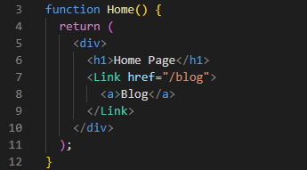

The anchor gives the visual link to press like a button and the href tells the link where to take you to. You can do the same in the destination page to tell it to go back to the home page. The href in this case is simply “/”.

Navigating to dynamic routes is also relatively easy. You could create a link for each of the items:

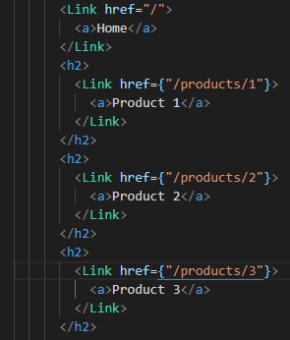 But you can see here that this will very quickly become unsuitable and we have a dynamic range here so the number could be anything from 3 to 3 million… A more appropriate solution would be to pass the product id as a prop to the component. 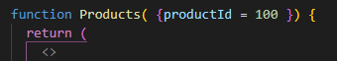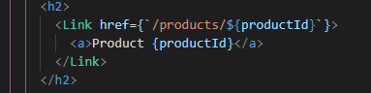

Also something to keep in mind is the ‘replace’ prop which can be added to the link div. 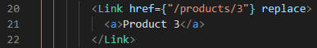

When pressing back from a page that has been linked to in this manner the url will reset to the home page.

**Navigating Programmatically**

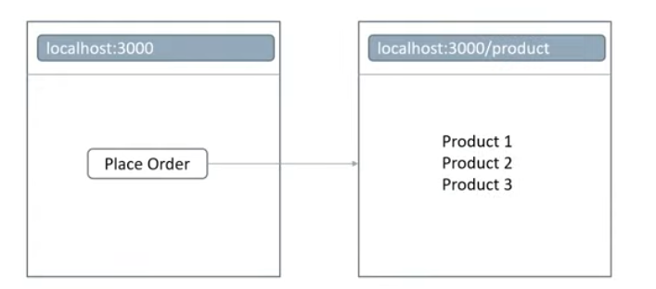

The scenario here is that on occasion it will be necessary to programmatically navigate to a new page after an event has occurred. Here we have a place order page and on the click we want to place the order which will return us to the product page. Perhaps a similar example for my application would be the programmed navigation that would follow a new user signing up to the service and then being sent to their new profile page.

The logic will all take place in the onClick handler function and the useRouter hook is the key here. One of the many router methods is router.push() which takes in the destination url as it’s argument. It has other useful parameters as well which may be useful down the line. We’re passing in the products href but any href that has been used could be used instead. This includes dynamic and nested routes. There is also router.replace which replaces the history instead of pushing the route onto the stack. This will make sense later.

Custom 404 page

In any next.js application, if you navigate to a page that does not exist, a default 404 page will be loaded instead. If for any reason you want to create a custom version of this all you need do is place a 404.js file into the pages folder.

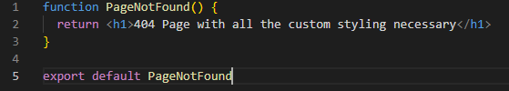

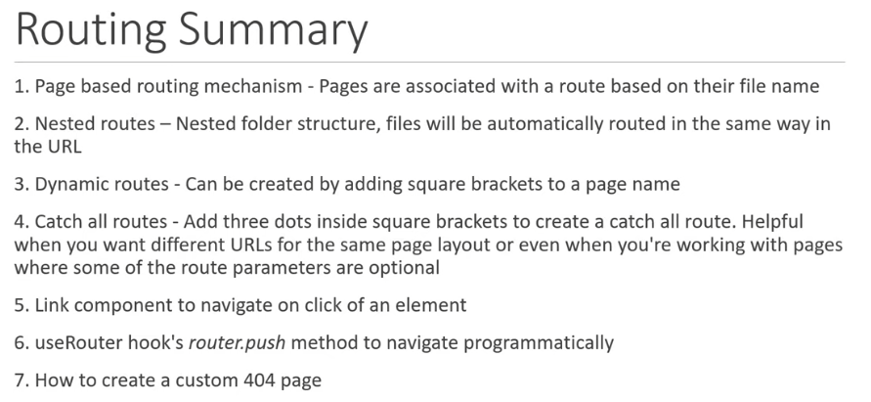

### Pre-rendering and Data Fetching

### What is it and why?

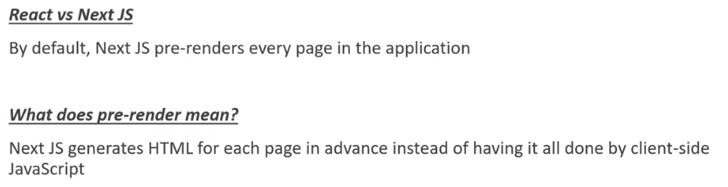

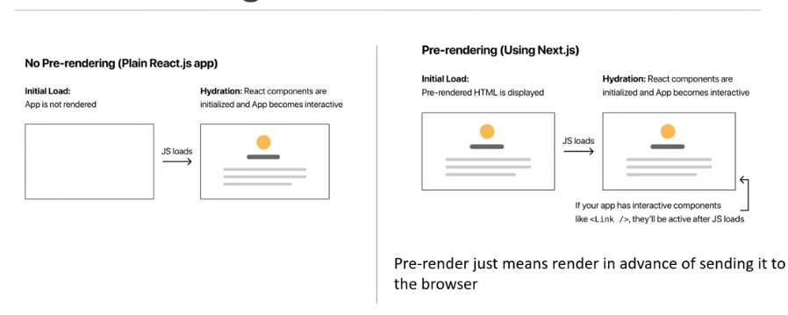

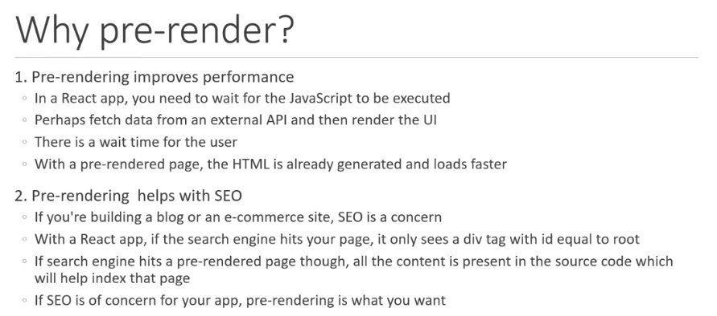

### Static Generation

What is it?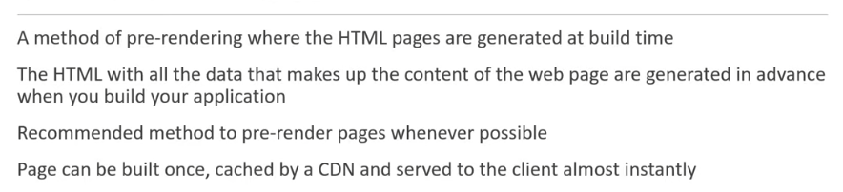

How does it work?

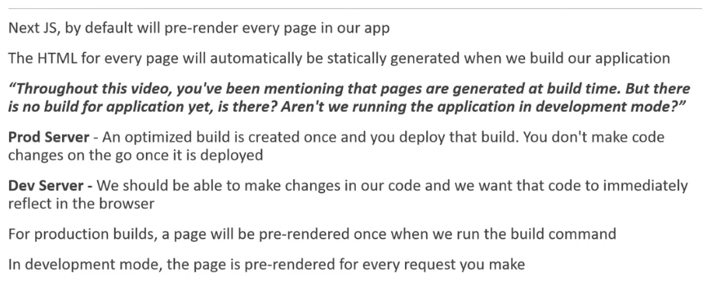

So, while developing an application you don’t need to worry about static generation. It is important to consider during the production process and will need to be addressed when you BUILD an application but this will be covered later in the tutorial.

In summary:

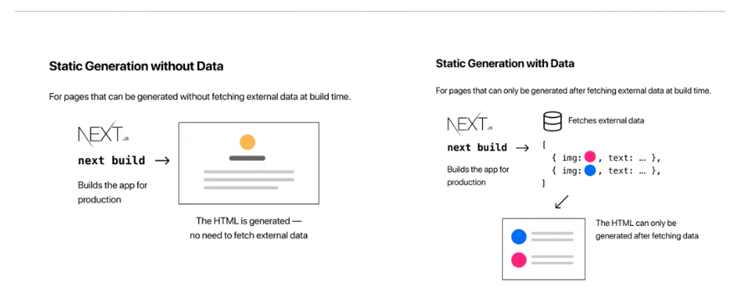

So Static Generation will generate the html for ALL the pages of a web-application including any data that may need to be fetched through an api or .json file

**Static Generation with getStaticProps**

For this section we will be using {JSON} Placeholder: <https://jsonplaceholder.typicode.com/>

In next.js, when you export a page component, you can also export an async function called ‘getStaticProps’. If you do export this function, it will run at build time (in production) and inside the function you can fetch external data and send it as props to the page.

Here’s an example of what the export will look like:

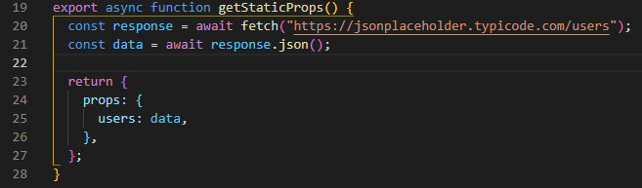

So when calling the function we get a response and data. We use the fetch function to fetch the data from a particular source (in this case json placeholder). Then we assign the fetch response to data and return that data as props to our rendering function as the props argument. It can also be destructured to the specific prop we are looking for which is what is done in the example here:

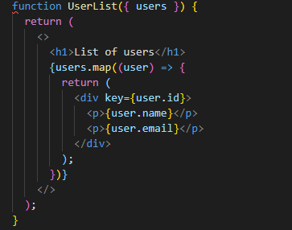

You can see if you ‘hard refresh’ the page and look at the source code, you can see that the page pre-renders all the information of the users. It is easy to see why this would help with SEO.

All you need do is define the async function, ‘getStaticProps’, fetch your data within the function and return an object with the necessary props. Those props will then be available to use within your component.

This process defined above is not, however, how you would typically write an application. In the case above with users, the convention would be to have a separate component called user that the user information would be passed to as props. So, lets do that - but where should we place this component. The answer is not what I was expecting. We do not place it inside the pages folder and here’s why…

When building a next.js application, the pages folder is unique - it provides automatic routing and access to functions like the one used above, getStaticProps. These benefits, however, should not be available for the presentation side of our application and should not be placed inside the pages folder. They should be placed in a separate folder within the file structure called components. The name isn’t a strict convention but in this case ‘components’ makes sense.

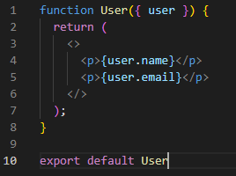 Here is our user component.

Now we need to import this component into our users.js file

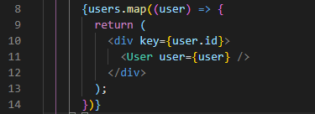

For more information about the key given to the div tag, read here: <https://reactjs.org/docs/lists-and-keys.html>

“A “key” is a special string attribute you need to include when creating lists of elements.”

The difference here between creating a component within pages or within components is as follows:

If you want to expose some UI as a route in your application, create it as a page

If you’re simply wishing to adhere to the component-based architecture and organise your jsx, go with components. Components do not need the special features that are provided to pages within an application.

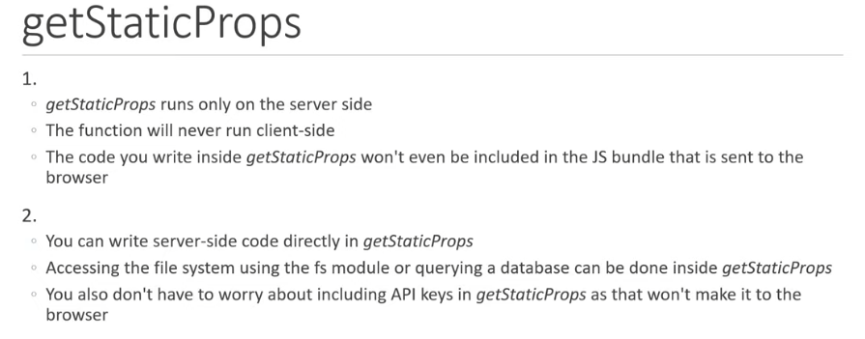 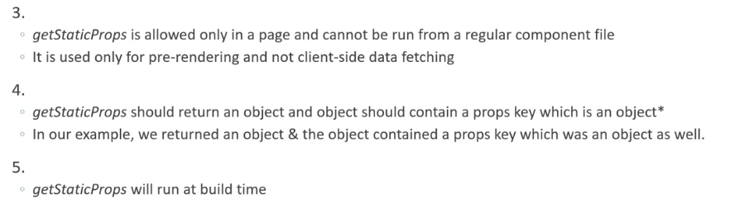

With point 5, this obviously is not the same in development mode. It runs on every update in development mode otherwise you’d have to build every time in order to see it run.

### Inspecting Static Generation Builds

We are going to ‘build’ the application now. First step is to delete any pre-existing ‘.next’ folder.

Then we will use the build command ‘yarn build’ to create our build. Lets focus on the terminal after this is completed.

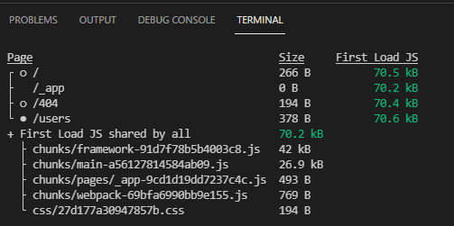

Page - This is the route.

Size - Refers to the size of assets downloaded when navigating to the corresponding page client-side.

First Load JS - refers to the size of the assets downloaded from the server when visiting the page.

First Load JS shared by all - this refers to the code that is downloaded irrespective of the route we are hitting in the browser. This contains the css from globals.css, some webpack runtime code, framework code, node-modules render code (like React for example) and some code related to the pages and components in our application. There is also some code from the _app.js file. This will be covered later in the series but for now, this is a component that wraps every page in the application. You can see how the size and first load size is additive. The green colour is also dynamic and will change to amber or red depending on performance.

Below this table is a key:



The hollow circle does as it states above. Therefore the _app.js file is static and does not fetch any data. The same can be said for the 404 route. Users route has a filled circle. Again, using the key we can see that this file uses SSG which is Static Side Generation and means that the page is being automatically generated with HTML + JSON - not just HTML. This page uses getStaticProps to fetch the data. This goes some way to enforcing the idea of pre-rendering within our application.

### Running Static Generation Builds

Run yarn start to start up the build that we have just created in the previous section. Opening up the browser will show much the same as we see in the dev server. It’s worth looking at the Network tab in the development tools.

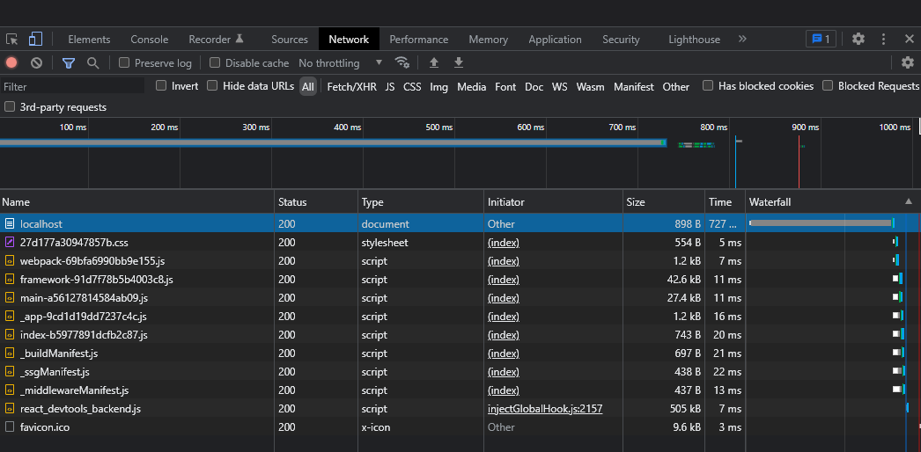

You can see what has been called to the server and how the pre-rendering works as well as file sizes and paths. You can see here that the code related to users is not directly loaded here despite the file being present in the pages folder in .next. Next.js is aware that, in our app, there is no way for a user to navigate to the users page from the index page and that is why it doesn’t load. You can edit the url and get to the page that way at which point the users ‘chunk’ will be loaded along with the page:

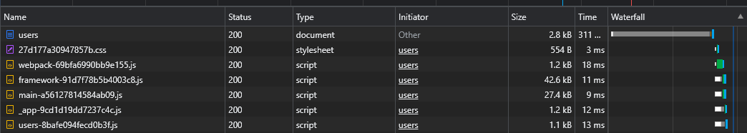

What’s import here to remember is that the chunks that are loaded are relevant for the page you are loading. If however we include a link to the users page from the home page then lets see what happens: 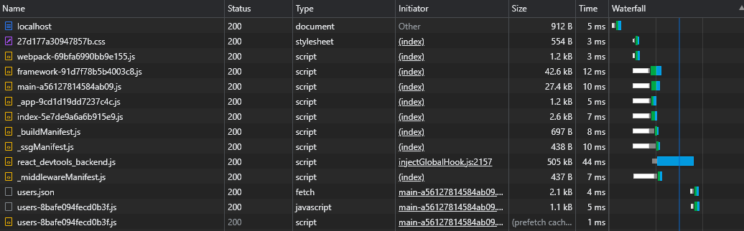

Now we can see here that due to the link being present, everything relating to the user page is being preloaded on the home page. This means that clicking the link will almost instentaniously take you to the users page. If yo clear the network list and then click on the link you’ll see that no loading occurs because everything required for that page has already been fetched. This is the default behaviour in next.js.



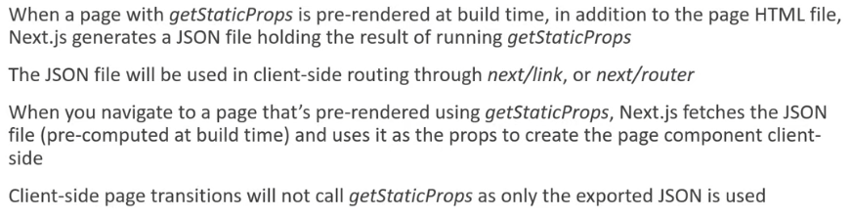

In summary:

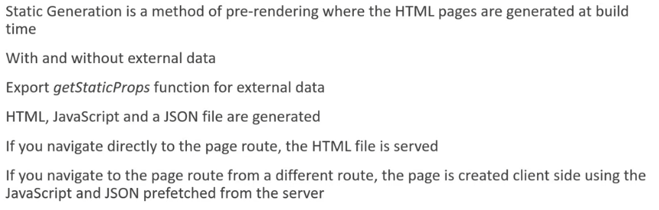

### Mater-Detail UI Pattern

Also called List-Detail Pattern

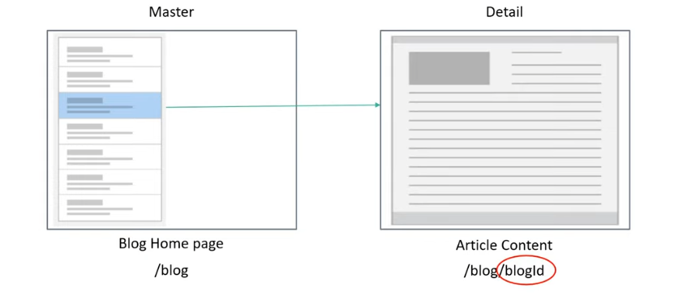

This relates very well to a blogging website where you have a list of blog posts and on pressing a link on a post you are taken to that post’s details. Already we have discussed dynamic page routes but now let’s focus on how to generate pages with dynamic parameters statically. We’ll use json placeholder again for this. The first part of the process has already been covered on pages 16 and 17 - using the getStaticProps function and bringing in the data through the fetch method then converting the response to json and returning it as props to the component. Now all the posts are available to us.

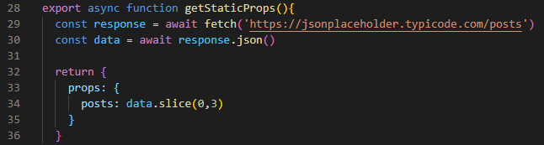There are 100 posts so the slice method is only retrieving the first 3!

Now we need to access the first post only using dynamic routing so first of we follow some of what was covered on page 9. Inside our posts folder we have an index.js file which will give us all 3 of the posts and displays them. When we click on the first post we want to go to it and see what it’s contents is. This will be a dynamic component so as on page 9 the file will need to be in square brackets. We have a simple function that will return the post id, title and body bit we need to bring into the function the post that was clicked. This is where getStaticProps comes in again. This time, however, the url that we will be placing into the fetch method will need to be ‘https:blahblahblah/posts/1’ but this ‘1’ needs to be dynamically routed.

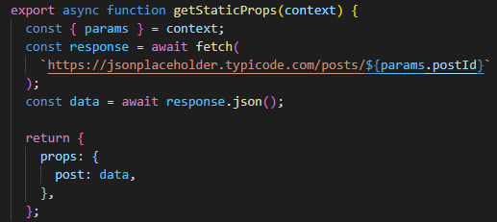

Here we can see that the first part of the getStaticProps function works as normal but with one change - getStaticProps now has an argument. The convention is to call the argument (context). This parameter is an object which contains a key called params which we need to destructure. This context will contain the postId route parameter. So on the API endpoint we use string interpolation to add the dynamically created postId at the end. All this being done and a link on the homepage to go to posts page then creating a link dynamically for each post. If you click on one of the posts the expectation is that you will be taken to that post and the post is displayed. The URL works but the page will not load and we get this error:

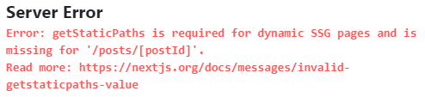

Lets delve into why that is!

**getStaticPaths**

This has to do with path parameters. Next.js needs to be told what to expect when rendering static html pages with dynamic urls.

The getStaticPaths function is asynchronous and returns an object. This object must contain a ‘paths’ key. This key determines which paths will be statically generated at build time. The key is an array of objects. Each object contains a ‘params’ key which in turn is an object that contains the route parameter with its value (make sure this value is a string).

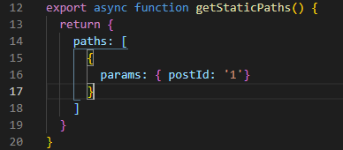 This is a simplified approach.

Here we have the params object returning a single route parameter with it’s value. We know, however, that in our example we have 3 possible parameters because we have fetched the data from the url in index.js and sliced only the first 3 posts from that data source: 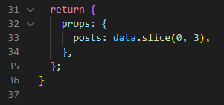

Therefore the solution woud be to include all the paths as separate objects inside the paths array returned in the getStaticPaths function.

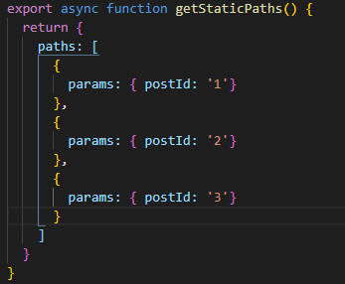

There is one more thing to add here. In our return statement, along with our ‘paths:’ key, we must also return another key called fallback. This will be covered later in the tutorial but for now lets set this to false.

Now let’s build this and look at the output.

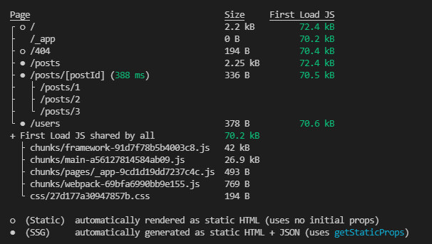

We can now see that the postId path contains the three paths that have been created using getStaticPaths. Next.js generates the paths through this getStaticPaths function. This now means that if we go to the posts page then all three .json files will be loaded at that point because the browser has noted that there are three links available on that page and has pre-loaded the .json files for those links. That means that on clicking them we are immediately sent to those pages without any extra loading time. If we were to navigate directly from the home page to one of the individual productid pages then the html for that page would have to be loaded instead of the .json file. What we’re really trying to get at here is that pre-fetching occurs in the browser when there are direct links to further pages from the one you are currently on. If we land at the home page first then we pre-fetch the .json files for users and posts.

So far we’ve hard coded the paths for the three postId’s that we have fetched from our external URL through the getStaticProps function in the index.js page of our posts folder. This has made things easier in terms of showing how the getStaticPaths function performs and it’s effect on the build of the app. This doesn’t not work in a practical application though. There will be multiple posts and in this case there are 100 possible posts we could fetch and these paths should be generated dynamically not hard coded as they are above. Let’s deal with this now.

Firstly we’re removing the slice method from our data fetching on the getStaticProps function in the index.js component. Now we’re fetching all 100 posts. We now need to tell next.js that we’re receiving these 100 posts and not the 3 which have been hardcoded in [postId].js

What we need is an array of 100 objects where each object contains a params key and each params key contains an object with the postId key being assigned to each post’s id. If that makes sense…

It might be possible to call in the total number of posts through your api but in our case this is not possible so we need to use the /posts api which receives all 100 posts (as we are doing in the index.js file) along with their post ids. It is possible then to just extract the post ids to generate the paths array that we need to create.

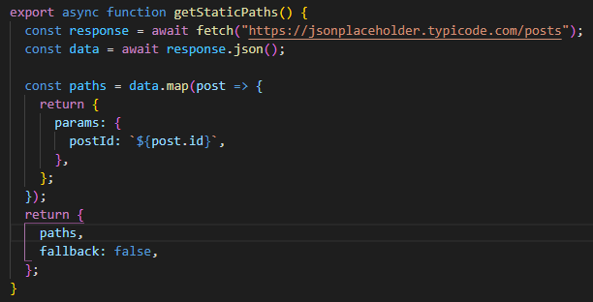

So, we can fetch data from an api inside the getStaticPaths() function and here we are doing so and returning ALL of the posts in the constant ‘data’. This is an array of post objects, each containing a number of elements: 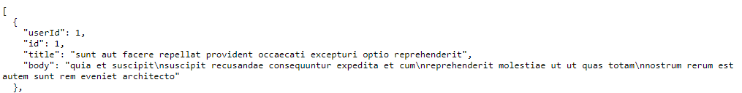

In our return statement for getStaticPaths, we need a ‘paths’ key which contains objects which contain a params key containing each url. There could be thousands of these so we need to dynamically generate them. To do this we map the data assigning each object in the array to post and performing a function on each post returning a params key object where the postId is set to post.id. <https://www.w3schools.com/jsref/jsref_map.asp> or <https://developer.mozilla.org/en-US/docs/Web/JavaScript/Reference/Global_Objects/Array/map> will walk through the mapping process clearly.

Now lets build this new app that we’ve created with dynamic url pre-rendering.

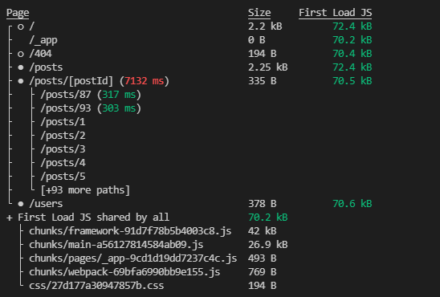

Now we can see that every single path has been generated within the build. There are .json and .html files for each of these paths.

Now, remember that addition key present in the getStaticPaths method, ‘**fallback**’? Now we’re going to focus on that. First thing to note here is that this key is MANDATORY which is why it has been included in the above tutorial despite not knowing what it was doing. There are three possible settings for this key and we will cover each one separately:

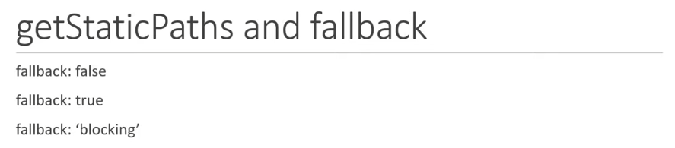

Let’s look at ‘false’ first.

Firstly just a quick reminder that our postId.js page is something we want to statically render which means we need to use getStaticProps to fetch content from an external api. We also want this page to dynamically generate urls which means we MUST tell next.js that we are doing this with the getStaticPaths function. We’re returning post ids from 1 to 100 here. For this first example we will return the postId to its previous state where it was only generating the first 3 post urls. So in the index.js file we reinstate the slice function and in the postId.js file we comment out the logic retrieving all the posts and their individual ids and simply use the hard coded post ids.

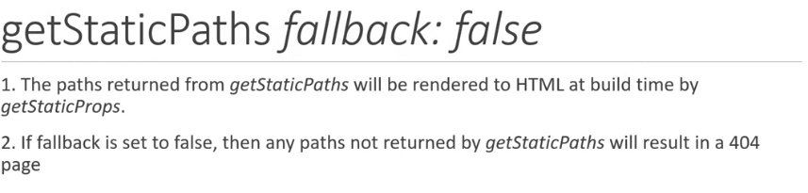

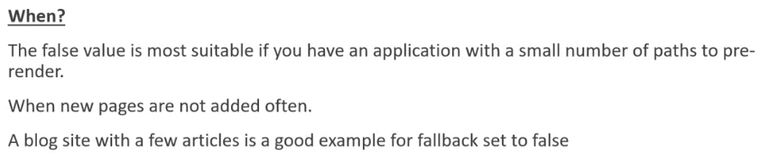

This is a relatively simple concept to understand. It starts to get much more complicated with fallback: true

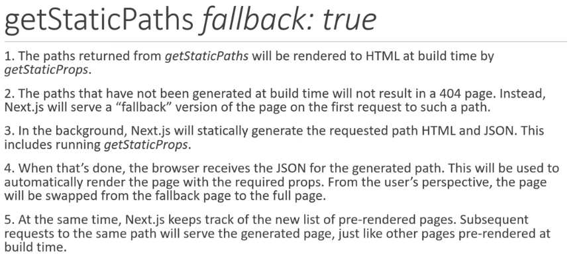

What this effectively means is that a conditional statement is required for when the props to render a page are not initially available. If the props are not rendered then next.js will, in the background, generate the required .json and .html files for this page and while the user is waiting for this to happen another page will be displayed instead which, effectively, will act as a loading page. Once the required files are available then the user is redirected to the right page. Next.js keeps track of these generated pages and will serve them instead of generating ANOTHER new .json and .html.

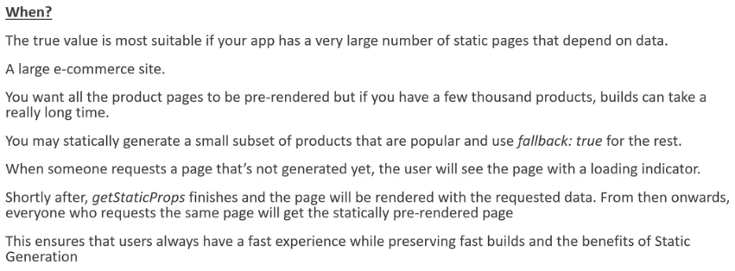

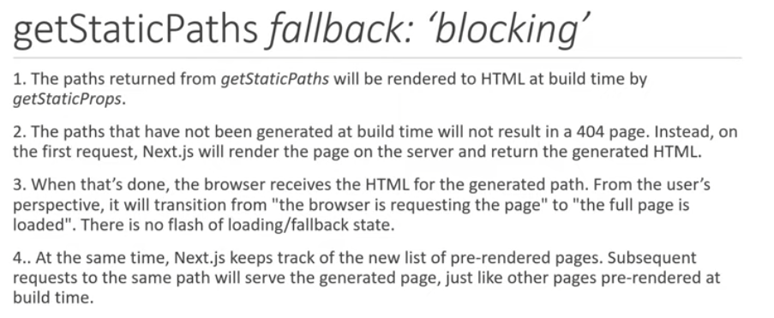

This is essentially very similar to fallback: true. The difference is that there is no loading screen and we simply wait for next.js to create the required .html and .json files when a new page is loaded in the browser. This results in considerably higher loading times for a page.

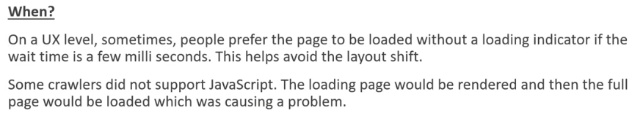

The next.js team suggest using fallback: true unless it causes problems to do so - in which case set it to ‘blocking’.

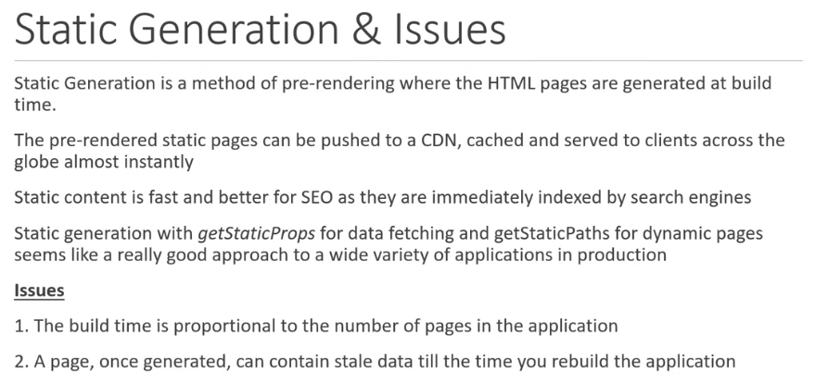

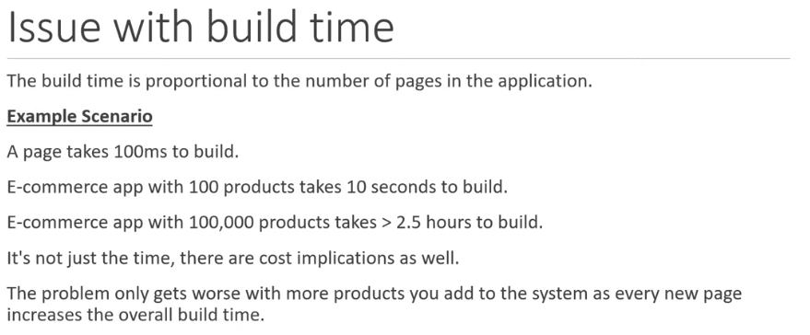

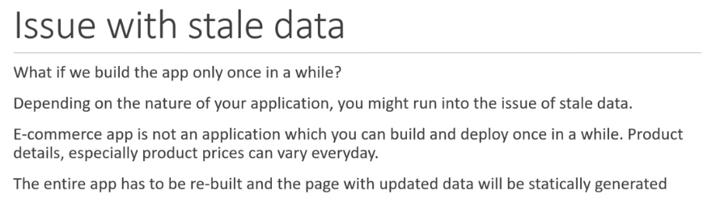

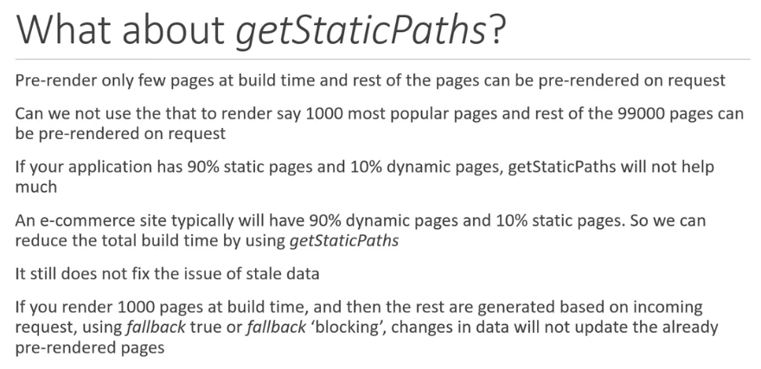

This is a serious problem so we need to address it in next.js with Incremental Static Regeneration (ISR).

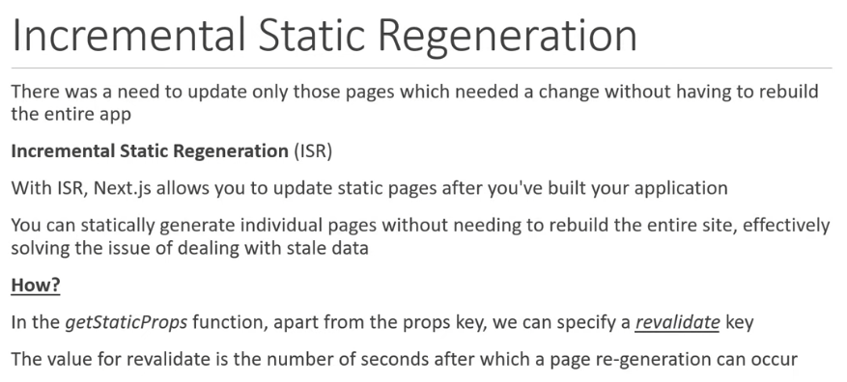

In order to show this, we’ve made a products page that displays products that are served to the browser through a locally hosted api. This is done using the json server package. Very handy! We can see that when the pages are loaded the function as expected with the previous examples above relating to posts. New files are created in next.js for the dynamic content and the static product has a .json and .html file pre-built. Any requests to the other 2 products will result in a new .json and .html file being created and used for subsequent requests. What is interesting here is what happens when the price of a product (say product 2 which we have already fetched) is changed in our db.json file. If we change it and look at our <http://localhost:4000/products> we can see an update in the price. This will not be reflected within the application however as the .html and .json files have already been generated for this url. This ‘price update’ creates stale data and our application is no longer accurately reflecting the price of the product! Now we will look at how to implement the revalidate key within the app to fix this problem.

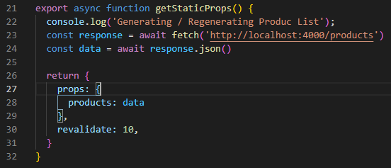

As mentioned above, we have now added the revalidate key. This is to the getStaticProps function in the index.js file for our products page. We have also included a log statement within the function to get an understanding of how this revalidate key functions. Now running the build command will produce the following:

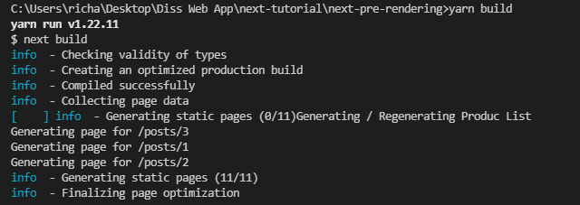

Here we can see the console statement ‘Generating / Regenerating…’.

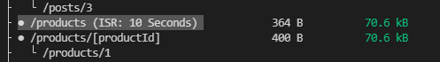

Also here we can see the implementation of the revalidate key.

Now if we build the app and start it and head over to the products page, at first we do not get the ‘Generating / Regenerating…’ statement BUT wait 10 seconds and refresh the page and all of a sudden we do. This is the same console log message that was created when originally we built the app. The same getStaticProps function is being forced to run here ever 10 seconds to update the page .html and .json with new data if the data has changed! Nice!

It's worth nothing though that within those 10 seconds, the page can be loaded 100 times and it will always load the cached version of the page.

There is a small difference though with the way this ISR is working as apposed to building a page and running it. In our example we can update the price of product 1 in the database and hard reset the page and obviously we will first not see any change. If we check the json server we can see that the db is updated and there is a new price in the DB. Now the specified elapsed time has passed (the time we have indicated with the ‘revalidate key: 30’ (so here it is 30 seconds). Now if we reload the page we get the console log statement which shows us that the setStaticProps function has been executed again but we DO NOT see an updated page and the price remains the same. If we refresh the page ONE MORE TIME, then the price has finally updated.

Next.js runs on something called the ‘Stale While Revalidate’ strategy. Lets see how this works.

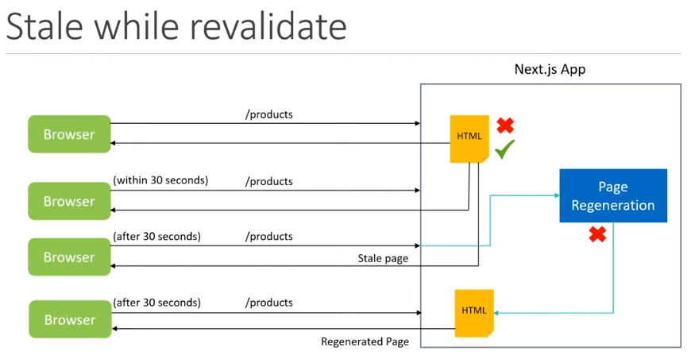

First the static html page will be served to the browser. Any calls to the app to serve the same page WITHIN the time set out in the revalidate key will call the same cached .html page regardless of any changes in the data that may have happened. After the time set out be the revalidate key and on refreshing the page, the app will STILL send the original cached .html page but this time a new request will be sent to the app to regenerate the page. The very next time the page is served, the newly generated .html will be served instead and the cycle will begin again. The red X and tick here represent what would happen if the page regeneration process were to fail for some reason. The app would serve the original cached version of the page in this case.

You can see within the network tab in developer mode on the browser more about how this process is actually being run in the cache control headers:

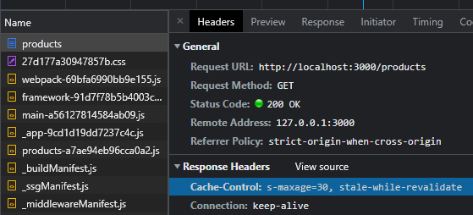

The same process as was done to the product list page can now be applied to the individual product file [productId].js. We’ll make a different log statement inside the getStaticProps function here so we can see the separate regenerations.

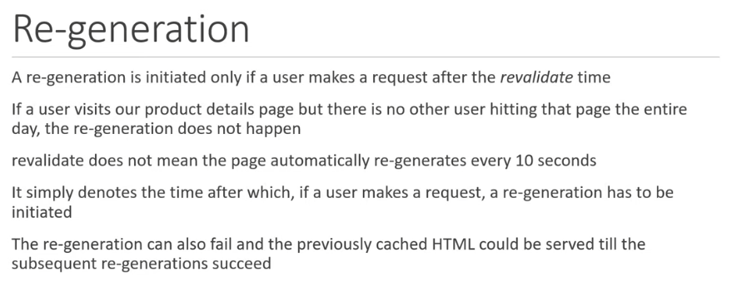OK so here we have it. ISR is a great way to deal with situations where information coming from your api is changing for whatever reason. The slight issue you will have is that for a set amount of time the user WILL see stale data. With an e-commerce web application this may well be adequate for your needs. If there is low footfall on the application then you might set the revalidate time to quite high but if you are serving many users and there is high traffic from the api as well then it might be necessary to reduce that timer right down to 1 second!

If the notion of still displaying stale data is not allowable at all then there is another solution you can use - and that is SERVER-SIDE RENDERING

### Server-Side Rendering

A quick summary of where we’re at:

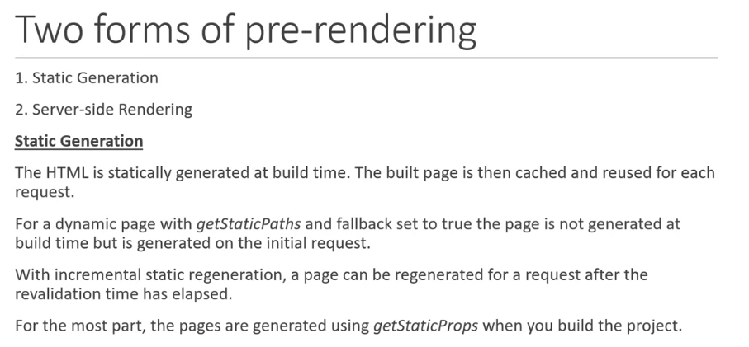

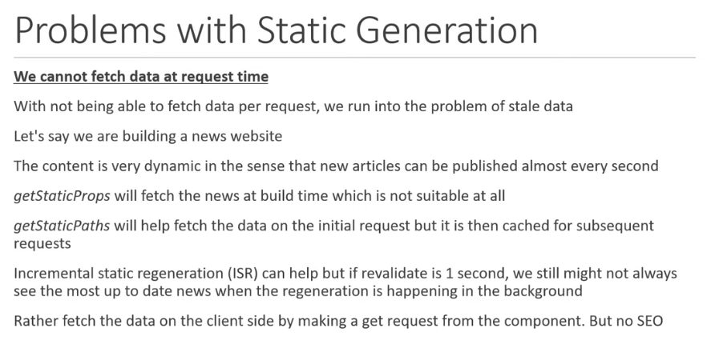

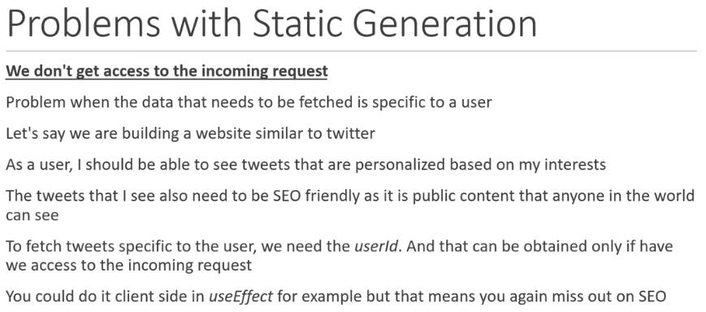

To overcome the above two problems, next.js offers up a second option for rendering: Server-side Rendering.

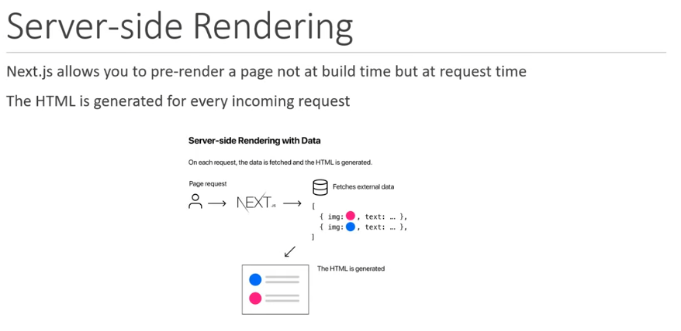

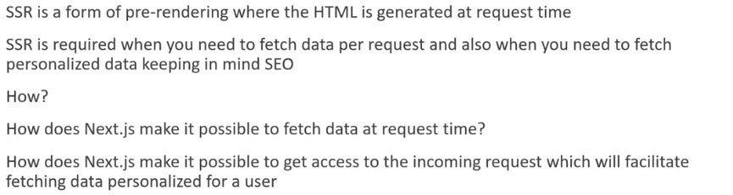

So to illustrate this with an example we will imagine a news website where articles will need to be constantly kept up to date. As a result, static generation is not appropriate - we need SSG to make sure that the users of the website are getting the most up-to-date information. First we add some new lines to our db.json file. A news key with an array of 3 articles. In our pages folder we create a new folder called ‘news’ with it’s index.js file. In this file we create a simple function for returning jsx. NOW we use the getServerSideProps() function which works in much the same way that getStaticProps() does - with a fetch function and a response that we turn into json:

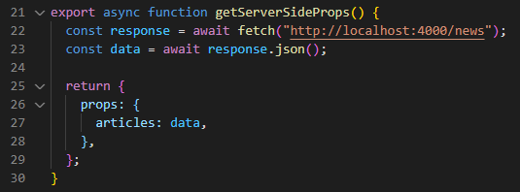

You can see that our return statement is an object containing the props key which is an object containing the articles key and the attached data from the tech request. This is then brought in as an argument for the page generation function. The data is brought in as props but I don’t know why it’s not working for me by simply using ‘props’ as the argument. You can also bring in the specific props key which in this case is {articles}. This seems to work fine for me.

Now we load up the dev server and browser and navigate to the news page. What’s happening is that when we navigate over, this is when the next.js server receives the request and upon receiving this, next.js runs the getServerSideProps function exported from the page. The data is fetched then and provided as props to the component. The html for the component is generated ON the server and THEN sent back to the browser.

One thing that will probably seem obvious is that this form of rendering is slower than static generation for obvious reasons. EVERY request is generating the html and sending it from the server to the browser.

ONLY USE THIS FORM OF RENDERING WHEN ABSOLUTELY NECESSARY BECAUSE OF THESE PERFORMANCE DISADVANTAGES

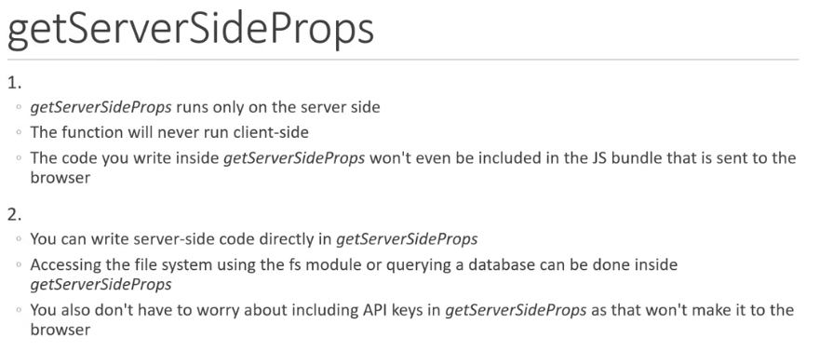 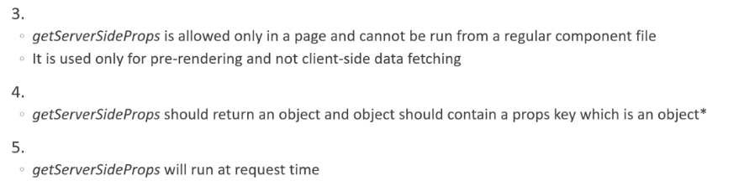

**SSR with Dynamic Parameters**

In our example here we want to create a page that filters the news articles by category. There are 3 articles we have, 2 with sport and one with politics.

We want our url to be ‘/news/politics’ or ‘/news/sport’. So we now have a nested dynamic route so will need to use the square brackets for the naming convention for next.js. Then we need to create the function for rendering the jsx but in order to fill it with the information we want from the api we must retrieve it using the getServerSideProps function. We have already used this to render a list of all the articles but now we need to use it to render a list of articles relating to a given category ONLY. We’ve also done this above in the posts tutorial. The way this is done in getServerSideProps is exactly the same as it is for getStaticProps. We include an argument for the function which is called ‘context’. This is of course a convention but you could call it anything you like. As we found out above, this context parameter is an object which contains a key called ‘params’. What we need to do then is destructure this parameter. The { params } object, in our example, contains the ‘category’ route parameter and can therefore also be destructured.

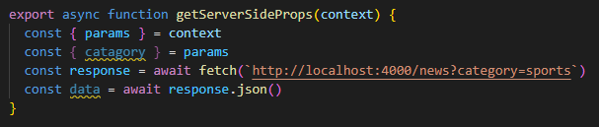

So far we’ve hard coded the category using the conventions that json server allow us within a url (this is specific to json server by the way). What we need, however, is a dynamic url where the specific category is shown. We can use string interpolation here and bring in the newly created category parameter.

**getServerSideProps context**

Delving deeper into this ‘context’ parameter. As we’ve already stated, ‘context’ is an object which contains the ‘params’ key. It also, however, contains a number of other keys. The full list can be found in the docs: { <https://nextjs.org/docs/api-reference/data-fetching/get-server-side-props>} . The two we will focus on here are:

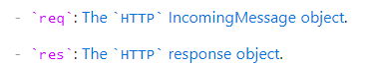

Here we are going to learn about setting and reading cookies from the req and res keys.

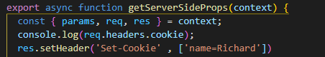

So, on our dynamic page rendering a list for a given category, we have the getServerSideProps function which takes in the context parameter. So far we have been using ONLY the params key but now we will also be using ‘req’ and ‘res’. Request and response keys. The log statement is to show us how ‘req’ is used and, through the loading of the web page, how the cookies are dealt with by the browser and next.js. res.setHeader allows us to add a cookie to the header which we have given a name. When we navigate to the sports or politics articles page we first get a log statement which only shows one cached cookie which relates to language setting but in the application tab of our browser we can see that the name ‘Richard’ has also been added to the cache. Now if we reload again, the name will appear in the log statement as well. We can see how this would be useful if you wanted to keep track of lets say a user who had logged in and were wanting to show data relating to that specific user.

Now we’ll look at the query object.

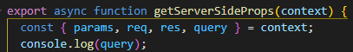

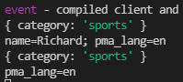

This query object contains the route parameter but this can be extracted from params anyway. Where it is useful is that if there are nested routes they can be accessed here as well. For instance:

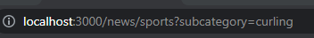 would yield the following query log statement:

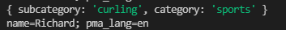

This will be useful particularly with my website when applying filters to a product search.

There are plenty more keys to look at so check out the url above for more information.

Now we’ll sum up the SSR section by looking at what happens when you build an app with SSR elements.



Now we’ve got a new symbol to deal with! Lambda!! I wonder what it’s for?



So in our file structure, within the .next folder tree we should not expect to see any html pages created.

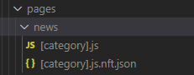 … good!

Now lets load up the index page for news followed by the list page for a specific category.

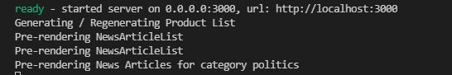

Here we can see that when the pages have been loaded the relevant getServerSideProps function has run and html has been created by the server and fed back to the client. What’s interesting is that I thought an html page would be stored after this had happened but of course that doesn’t happen. The htlm page is created by the request and is made by the server and sent to the client but it is not stored on the server after that point - more than anything, this is because we’re supposed to be working with ever changing data here and we don’t want any hard-coded stale data in an html file do we!>!

And here’s the crux of this SSR thing. 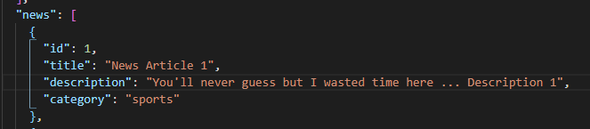

If we change something in the ‘db’ then reload the page, we have a brand-new description being displayed.

Both forms of pre-rendering have now been covered.

### Client-side Data Fetching

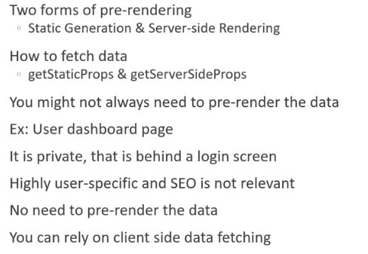

Casting our minds back to the tutorials on fetching data in a react app, the process of fetching client-side data is EXACTLY the same. We use the useState and useEffect hooks to give the function state and allow us to modify it.

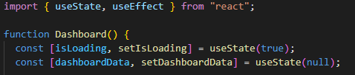

First we import the hooks.

It’s worth noting that this function has two parts, the first being a loading render while the asynchronous function is performed to fetch the data from the db. When that data has been fetched then we change from loading to rendering the required html.

We then need to create two state variables. The first is for dealing with the loading page and the second is for the dashboard info. Now we fetch the data in the useEffect hook. In the past tutorial on react we used axios to bring in data from an API. We’re using next.js to do it now. Whoop!

Now that we have state we need to bring data in by fetching it with the useEffect hook. Inside the useEffect hook we have a function that will fetch the data from the dashboard. The function will be asynchronous. Be specific with naming conventions. Don’t call it something silly. Then just as we have done previously, we use the fetch method with the url as it’s argument - convert it to json then what to do? Well we now have this data object with all our information in it so we need to send it over to our dashboard data variable via the setDashboardData function. I mentioned before that there is a loading render first. So once the data is ready to display, we can be done with the loading screen - hence setting the isLoading variable to false. The standard structure of the useEffect as we know it then follows. We’ve created the fetching function and now we need to run it inside the useEffect hook (‘invoke’ the function). The last thing here is the addition of the square brackets (adding an ‘empty dependency array’). This is because we want the useEffect hook to run only when the component first mounts. This is what it looks like.

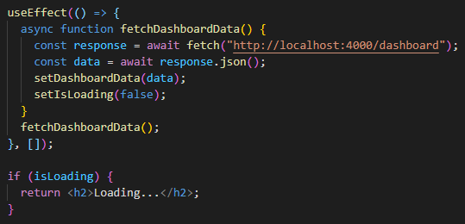

Now you can see the return statement is an if statement. If isLoading is true then we get the loading render otherwise we will render the page appropriately for what we want to show from the retrieved data:

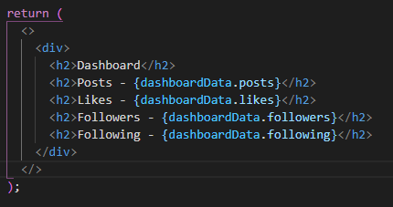

Next.js default behaviour is to pre-render pages so let’s see whether that’s happened here.

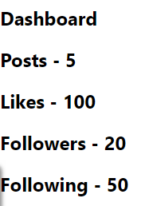 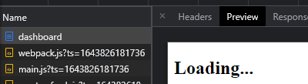

So here we can see what the browser is showing us on the left. On the right is the preview of the page which still shows the loading render. In next.js the pre-rendered page is based on the innitial state of the component.

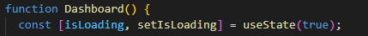Here’s the initial state…

This means that in these sorts of scenarios, the loading text is ALWAYS shown and the data is never pre-rendered. So, if you’re creating a page that is private, does not need SEO and is user specific then client-side rendering is the preferred choice. This is particularly hand when your page is split into components and you want to fetch data from the individual components and render them as and when the data is fetched rather than wait for the entire page data to be loaded. Components cannot exicute getStaticProps or getServerSideProps hence, client-side data fetching is the only possibility. #

One last thing to note…again.

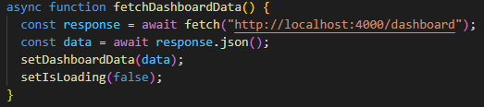

This pic is of the data fetching method used in this example. This is using the fetch API but you can use axios or any other data fetching library. The people at next.js have created a library for this which is called SWR

**SWR for Client-Side Data Fetching**

<https://swr.vercel.app/> for information.

We’re only looking at basic client-side data fetching here but SWR has a lot of extended functionality.

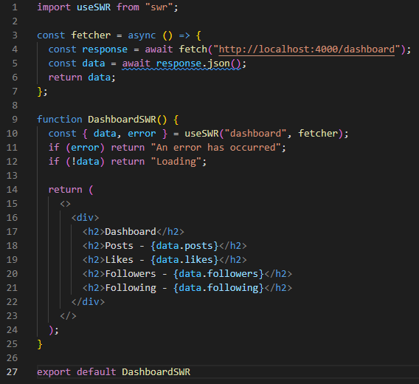

This is the basic structure for fetching client-side data using SWR. What’s worth noting is that this does not require the hooks at all AND a significant different when compared with the fetch api is that if there is a change in data in the source the webpage is updated straight away. Very handy. Would recommend!

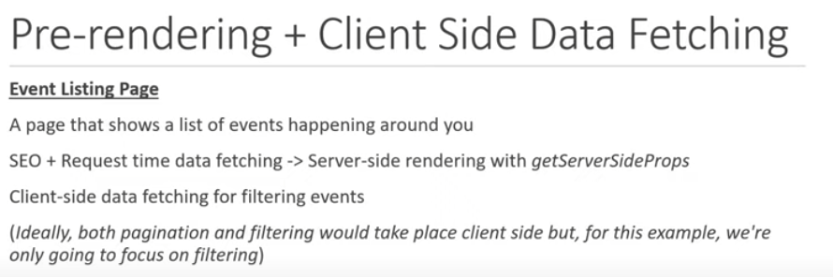

Right so we first get the data from json server and pre-render it server side:

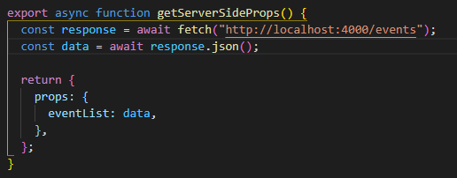

We’ve done this before…

Then as in previous examples we use this eventList key as the argument for our render function so that we can make a nice list of events using the .map method on the eventList. Now we display the list details in the jsx. But now we want to add the functionality to filter these events for a specific category. Normally you’d have a bar with categories or a drop-down menu or something but here we will simplify this with a button just filtering for sports. JSON-server is useful here because we can do this within the url string.



RIGHT, now we have this new data variable which contains our filtered list of objects. In order to display it client side we need to tie it to a variable. Here’s where the useState hook comes into play.

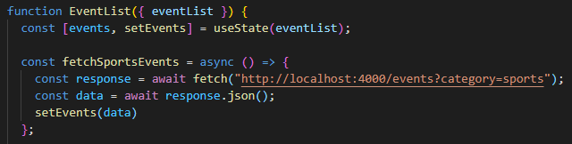

‘events’ now holds our sorted list of objects. So we simply replace eventList in the map method with events and bob’s your uncle. When the page first renders it is using SSR for the entire list. Then client side rendering takes in the full list and filters a new list and renders that for us.

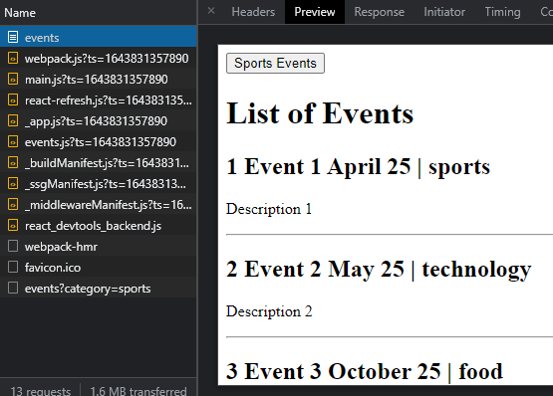

Here you can see that in the browser the list of events has been filtered but the preview is showing that there has been no change following the initial SSR. For SEO purposes, fetching all the objects in the list is what you want but then the client can sort through them to show what something tailored or specific. At the moment though, if we want to share the url here or book mark it, that won’t be possible as the url does not change for this client side rendering. There is a way around this which is known as **SHALLOW BROWSING/ROUTING.**

[**https://www.youtube.com/watch?v=yFvLLPBubfw&list=PLC3y8-rFHvwgC9mj0qv972IO5DmD-H0ZH&index=38**](https://www.youtube.com/watch?v=yFvLLPBubfw&list=PLC3y8-rFHvwgC9mj0qv972IO5DmD-H0ZH&index=38)

This concept makes sense ALMOST. It’s something that I will need to use in my application when applying filters to my backing tracks.

RIGHT, here ends the section on pre-rendering and data fetching. Here’s a summary.

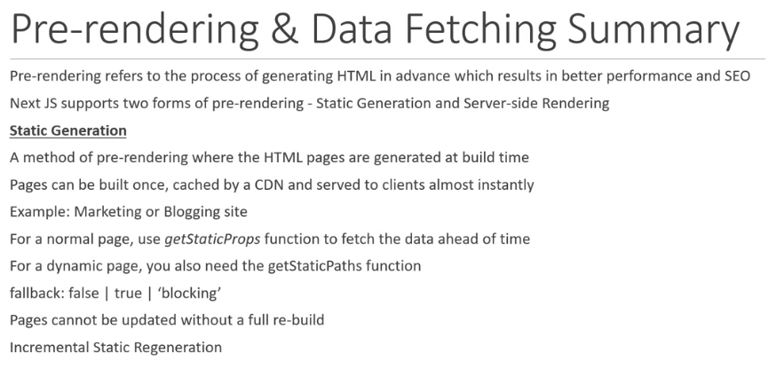

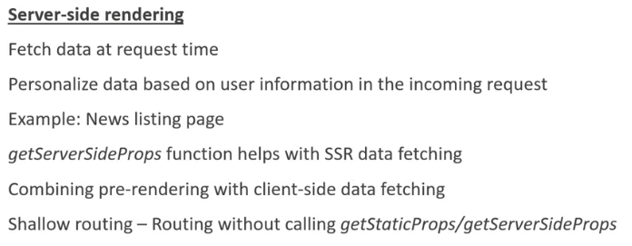

### API Routes

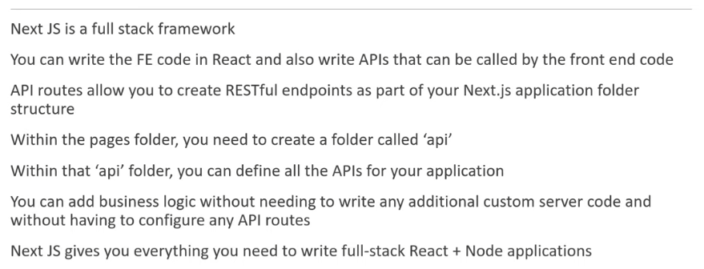

So lets get into this! New next app.

First thing to note is that all code within the API folder stays server-side so is NEVER seen by the client or in the browser.

In next.js you can create APIs within the pages folder WITHIN their OWN folder called api. The structure of those APIs works in much the same way that the pages structure does and the files get automatically mapped to a url.

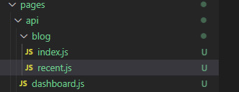

Each API file must default export a function which conventionally is called handler which handles a request and sends an appropriate response. The handler receives the request and response as parameters to help to serve the data that we want to send to the client.

In the tutorials below we will not be making requests to a db as this is a distraction and our focus here is just on the syntax and process of dealing with requests and responses, not where from…

**GET requests**

Step one is to create the API within the api folder:

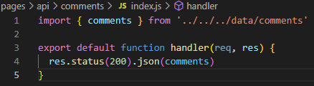

Step 2 is to create a page that loads this data on the click of a button. So we need to create a new page in the pages folder. For simplicity lets just make a comments.js page in the route. Now in that js file we need to have the jsx function. It needs to return in the jsx a button that we want to press to pull the data from the api:

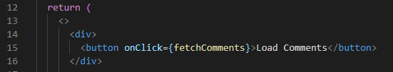

Now we work on the fetchComments function logic. This is an async function that first has to fetch the data from the api.

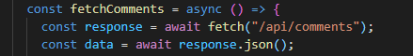

This data needs to be sent back to the jsx function so it needs to be set to a variable outside of this fetchComments function. So that means using a useState hook.

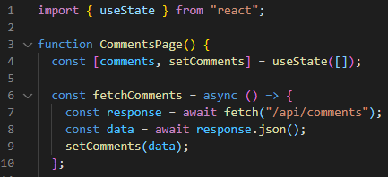

We have the useState snippet and we bring in the data using the setComments function. Now that we have this data we need to display it in the JSX. It’s an array of objects so we need to map them then for each object we return a div tag (where the id is unique!) which contains the id and text of each comment.

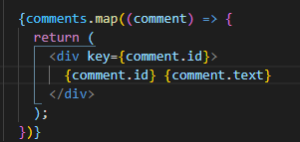

DONE

**POST Requests**

For this example we will use a scenario where a user will be able to create a comment and it will be stored in our comments.js file in the array in the data folder.

Step 1.

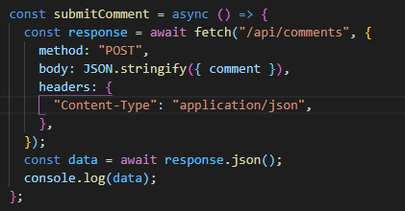

Within the fetch method we are now returning a SECOND parameter which is an object. This object contains a method, body and headers key. The method here is “POST” obvs. The body is a stringifying method which turns the raw JSON extracted from the comment variable into a nice little string for us. Headers… not sure yet.

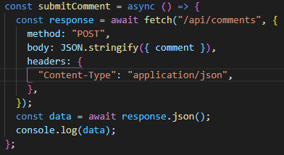

If we’re extracting something (which we are) then we need to send it over to a variable to be used right? So here comes another useState Hook!



Also don’t forget to await the response and assign it to a variable. We’ve also got a console statement here so we can see what the data actually includes.

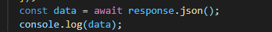

Console looks like this: 

Step 2.

Now, back in our API where we made our GET request we can now make the POST request. This now turns into an if statement because we will need to know what the client is sending the API before we execute some code. The if “GET” statement is essentially as was. Now we have the else if “POST” statement.

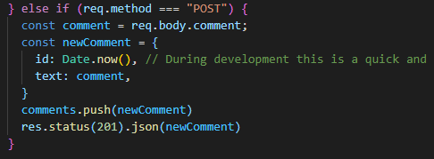

The req.body.comment refers to this:

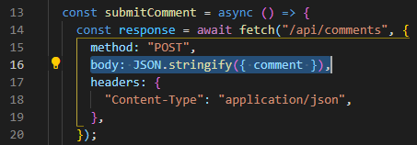

This is from the index.json file in the comments folder. We see that the key: body is set to a string containing JUST the comment.

We then need to create a new comment object where the id is set to the date.now() method (this is to ensure a unique id and good practise during the development process) and the text field of our newComment is the comment variable we have just brought in from the client side. We need to change the array in our data file not and add this new comment to it so we use the .push method appending the new comment. Now we respoond with this new comment. AS mentioned above, these examples are using a local data api so we have a temporary db here which is why the last line is what is is.

**Dynamic API Routes**

Now, so far we’ve learned GET and POST but in order to do DELETE we have to look at dynamic API routes. If we want to delete a comment we would need the individual ID of that comment which would require a dynamic API route as it would be ‘/api/comments/somespecifiedcommentId’.

First we need to create a dynamic api route which is done in much the same way (from a file structure perspective) as is done with routing in the pages folder. Square brackets FTW.

We have our normal handler function and we access the individual comment through the query method. This will be made more clear when we actually create the input to access it in the next section about deleting. The comment constant is assigned to a .find method that sifts over comments to find one where a comment.id is the same as the commentId given through the query method. This method returns a string (even though it’s a number in this case) so we need to parse it as an integer. We then return the json of that newly found comment.

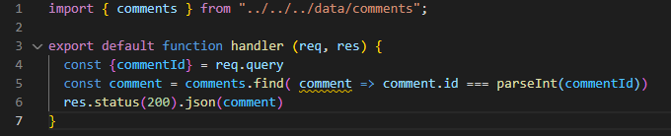

 This should now return a single comment.

**DELETE Requests**

There are 2 steps here. The first is a button next to each comment and onClick functionality which will send a delete request to the api when the button is clicked.

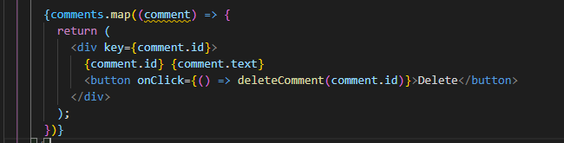

Now we go over to the dynamic api route, [commentId].js. Here we need to create a new if statement to work out whether a call to the api is either a “GET” or “DELETE” request. The “GET” statement remains as it was before. Now in the “DELETE” statement we STILL need to actually retrieve the individual comment as we’ve done in the “GET” request so this part stays the same. We’ve renamed the actual found object as deletedComment for clarity but it’s essentially the same.

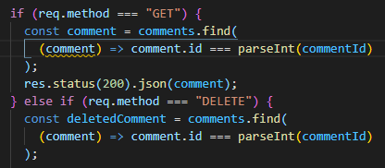

Now, in order to delete this comment from the array, we need to find this comment’s index. Handy .findIndex function here. <https://www.w3schools.com/jsref/jsref_findindex.asp>.

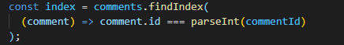

Then we use the splice method to remove 1 object at the position we have found through the findIndex method. <https://www.w3schools.com/jsref/jsref_splice.asp>



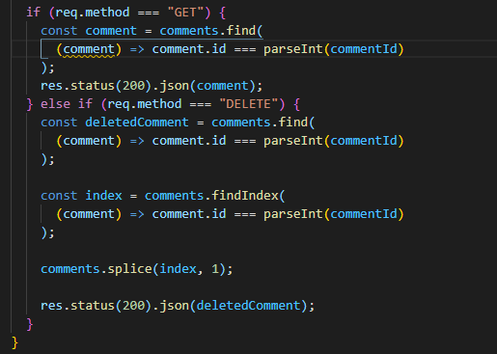

**PUSH requests**

**Catch All API Routes**

So we might want to use a number of parameters in the url like api/comments/comment1/subcomment2/ or even more ‘nested’ url additions. In this case we really need to use a catch all api route generator.

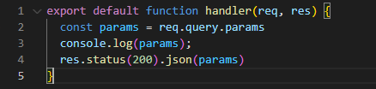

We’ve created a new file in the api folder called […params].js. This is very similar to the section above relating to catch all pages - see page 10. Works the same way and in this example we’ve logged the params and what is returned in the log statement is an array with each of the extra url parameters returned inside an array.

**APIs and Pre-rendering**

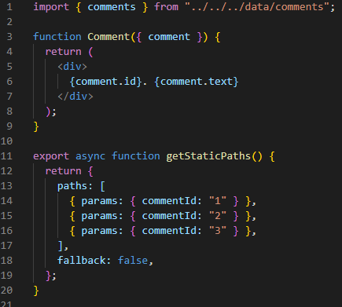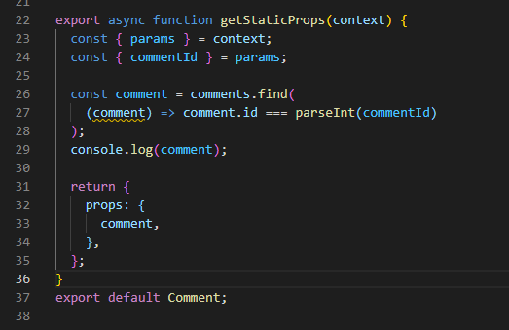

**API Routes Section Summary**

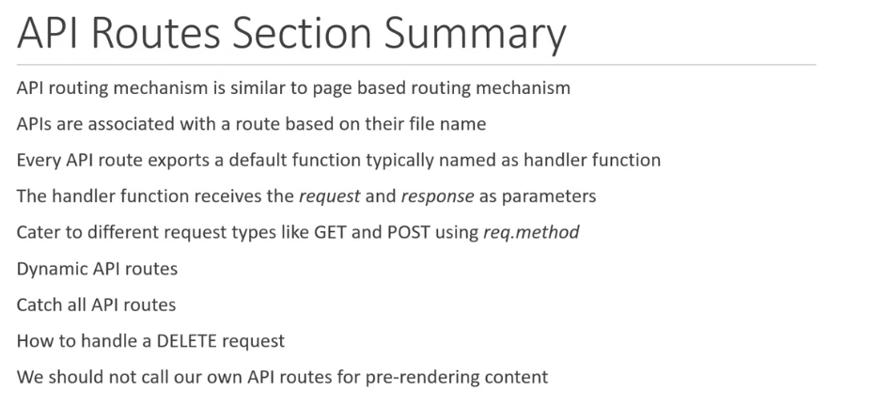

# Styling!

**Global Styles**

The important thing to note here is that any changes you wish to make to global styling are imported into the _app.js file which is the file from which your entire web app is loaded. Therefore, changes will be global.

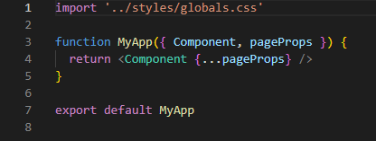

Here we can see the import.



This in the globals.css

Results in this:

 for our home page

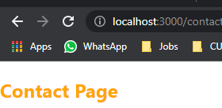



Etc

This is key to know when wanting to import external styles like Bootstrap:

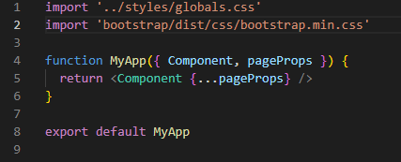

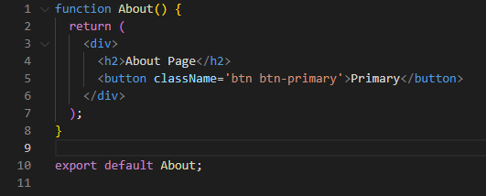

Now we have bootstrap styling in our about page. SIMPLE.

**Component level Styles**

CSS modules can be supported using a file naming convention. Next.js supports css modules for component level styling and locally scope css allowing you to use the same class name indifferent files without having to worry about naming collisions.

**SASS Support**

This is something that would be installed separately. If I decide to use SASS or SCSS then this should be revisited.

**CSS in JS**

You can use in-line styles within a component’s jsx but it is not the ‘go to approach’.

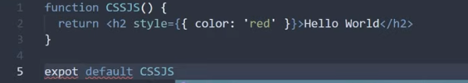

Here you could, instead install a package like styled-components with which you could apply a theme to your application.

Now in the _app.js file we can add the themeprovider object as an import and then wrap our component within.

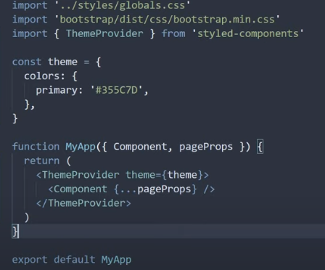

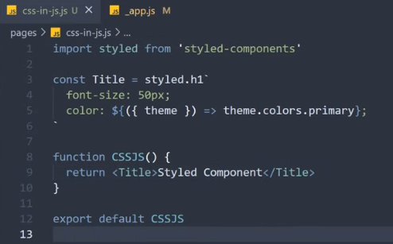

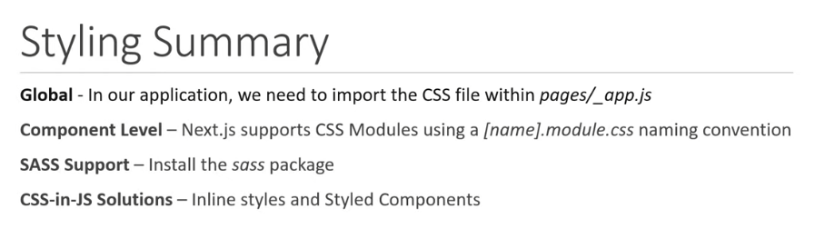



**App Layout**

This is where we can control what is being loaded onto each page. Focusing on the header and the footer first. We can create a site wide version of either or both of these and load them in with every page. This is a shared layout that we are producing here.

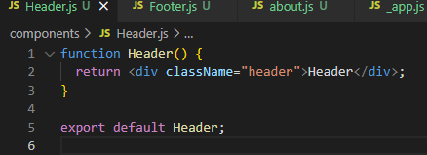

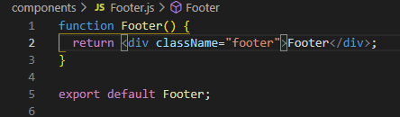

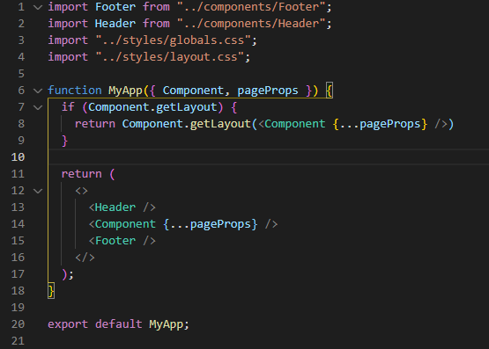

It’s also possible to implement a per page layout which will allow you to select which components to load. This is done using a function within the component which I’ve called in this example ‘PageLayout(page)’. The page in brackets is the page itself which in this case is the about page. You can already see this in action in the _app.js file above where we have implemented an if statement that will run when the page is loaded. If a pre-existing getLayout function exists within the component then the rules will be followed as per what is within the component and not the generic structure that is implemented in _app.js

Below is the about page with it’s PageLayout function telling next.js to only load this page with the content ‘{page}’ and the footer.

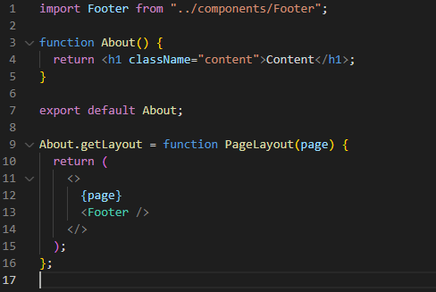

**Head Component**

When you think about SEO, the head can be very important as it holds information relevant to the page like a doc title and description but next.js does not populate this information by default. The head component within JS is your ticket to deal with this problem and by doing so, improve the SEO of your website.

Within an individual page this information can be added as follows:

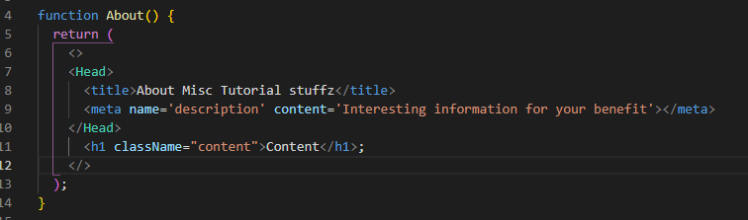

This is actually something that is already present in a newly created next.js app. If we look over at the auto-generated index.js file we can see that there is already a Head component which contains a title and meta tag as well as a link to an icon:

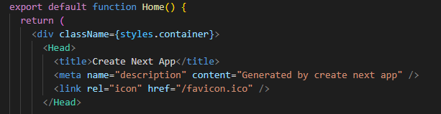

It can obviously become a bit tedious to create individual head tags for every single page so the way around this is you can create a single one that will expand to every page if you create it in the _app.js file.

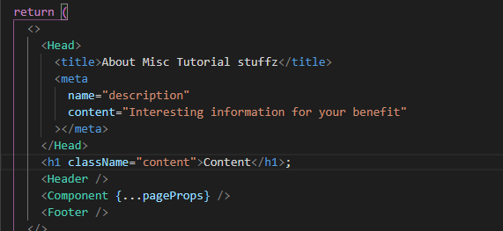

So it gets placed within the JSX as above.

This will apply to every page now but can be simply overwritten if you wish by writing incorporating a head tag within your individual components with its own title or meta tags.

It is also possible to add dynamic values to the head tags which is obviously necessary when creating dynamic pages!

It is recommended strongly to take full advantage of this head component when creating web applications - not just for it’s effect on SEO.

**Image Component**

For starters, images are placed in the public folder within the route directory of your application. Because they are placed there they can be referenced easily using next.js. In the example below you can see that the source for the image is a path with string literals. The path is simply a forward slash followed by the number as the files are directly placed inside the public folder which is in the route. This can obviously be expanded if you start using subfolders within your public folder, which you probably will do.

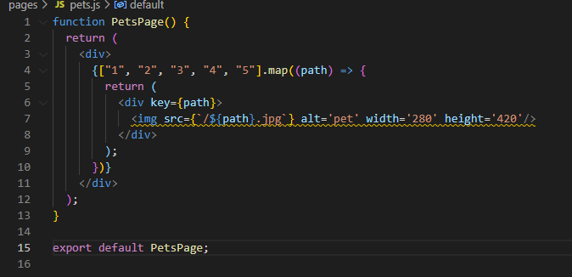

The linting produces an error here because you are being encouraged to use the next.js image component instead of what we have here which is an html image tag. The intention here is to see the difference between the two processes. When loading up this page now we can see that the process works and we have all the images rendered but what is worth focusing on here is that each of these images are loaded as full size files despite the specific width requirements being asked for:

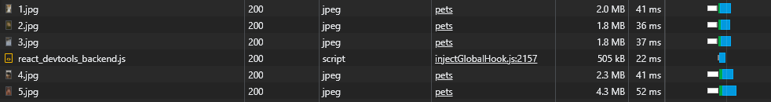

This is where the image component in next.js shines. It will optimise image rendering within an application.

It’s a very simple conversion in this case. We simply import the Head component and then replace the img html tag with <Image /> and keep the source as it was, the result will be a significant change in the load time for the page.

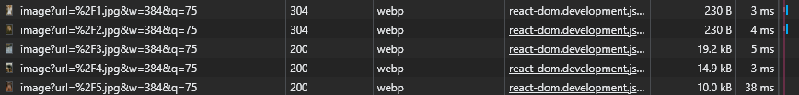

The pictures have been made much smaller as they are only being rendered at a specific size which we have dictated. They’re also rendered as webp images which is chrome’s answer to image rendering and is even more optimised.

So this is the first advantage of this image component. The second is lazy loading. This means that it will only load up the pictures it needs to display at the point you are on the page. At first only the first two images will be loaded because those are the only ones on the screen as the page loads. As you scroll down, more images will be loaded in.

Another useful trait of the image component is that it can load a placeholder for an image while it fetches the actual image from the server. This can be an actual blurred version of the ACTUAL picture. The catch is that in this case, the image source can not be dynamic.

In our example we will import the first image specifically.

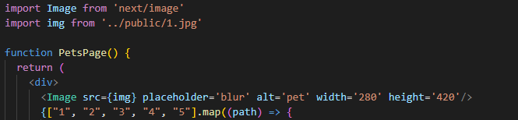

So we have the img object pointing to the import which is the 1.jpg file. The specs for the picture are unchanged from the above example and we’ve added the placeholder attribute and set it to ‘blur’. This results in a blurred version of the image being displayed until the actual image is ready to be rendered. This may not always be possible to do but when possible is worth including as it adds to the user experience. It is possible to do this with dynamic urls and required the incorporation of the ‘blurDataURL’ attribute. <https://nextjs.org/docs/api-reference/next/image#blurdataurl>

**Absolute Imports and Module Paths**

If we take a look at the _app.js file we can see that this file has relative imports. The header, footer and styles are all imported relative to the current file. Basically what this means it that the import comes in from a specific path that is defined in the import so each of the afore mentioned imports MUST include the ‘../’ prefix. This can be avoided using absolute imports…

In the route folder for your application make a new config file, jsconfig.js.

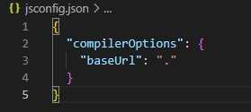

Here we’ve accessed the compiler option and set the base url to the app’s route folder. It was necessary to restart the server completely for this to take effect.

It’s also possible to create aliases for paths. This is just simple mapping and is useful to save time and clean things up a bit.



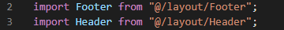

So we’ve not mapped the components/layout/ path to ‘@/layout/’.

**Static HTML Export**

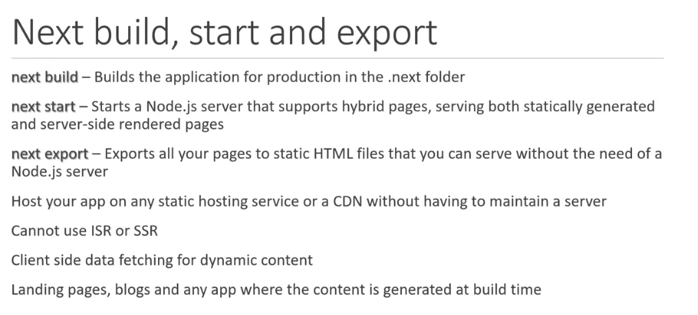

Honestly I don’t know that I’ll need this any time soon.

**TypeScript Support**

Next.js provides an integrated TS experience out of the box. You can set it up easily.

1. Create a file called tsconfig.json
2. Then try to start the dev server. You’ll get a warning stating you need to install some ts packages. So do this.
3. There. Done

Interestingly though we will get an error because our absolute imports are no longer functional and causing a problem. That’s because control of the imports has moved to the tsconfig.json file. SOOOOO all we have to do then is copy the config from our jsconfig.js file to our new tsconfig.json file. Restart the application and you’re all set! Below are some of the examples of types that can be incorporated into your next app. See <https://nextjs.org/docs/basic-features/typescript> for more information.

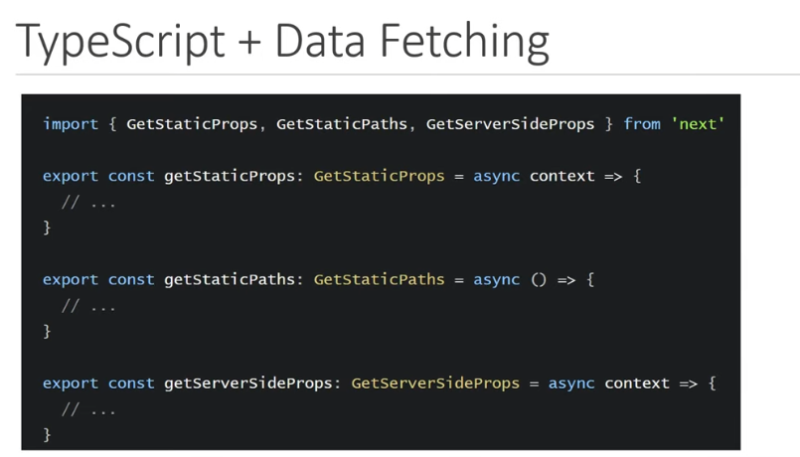

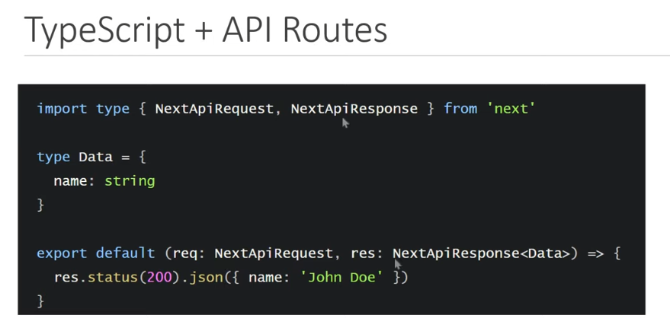

**Preview Mode**

This has to do with using a CMS. I will not be using a CMS with my application so this will not be relevant for me. If that changes, <https://nextjs.org/docs/advanced-features/preview-mode> for details.

**Redirects**

There are many situations where you might want a user to be redirected away from a page. A good example of a use case is that you are updating your website and have created a new blog path with improved functionality. Users may well have bookmarked the old path to your blog so adding a redirect sending anyone who uses the old url to the new one would be beneficial!

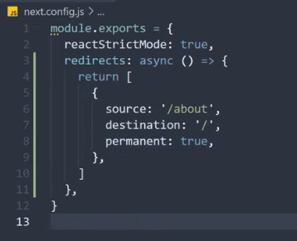

Here’s an example. In the next.config.js file we can create a redirects attribute which is an async function that returns objects and each one of those objects can be a specific redirect with 3 attributes. The source which is the original url, the destination which is where you want to send them instead and then we have the state which is permanent set to either true or false. So if a user navigates to the about page they will now be redirected to the home page. This redirect process occurs on the server-side and as a result no flash of content will be seen by the user improving user experience. It’s also a good idea for SEO. You can set permanent to false which will change the status code from 308 to 307 which is for temporary redirects. This would be used in a maintenance scenario. Obviously this doesn’t really matter for users but is important for SEO. Look at html redirects for more information on this. There is obviously significantly more that can be done here with redirecting. Below is an example of dynamic rerouting but there are plenty of other types or rerouting that are possible depending on the need of the application.

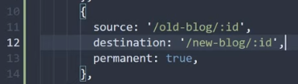

<https://nextjs.org/docs/api-reference/next.config.js/redirects> for more information!

**Environmental Variables**

Most applications that are deployed will require environmental variables. They are used to specify different values based on the environment you’re using (development, build etc) allowing you to safeguard information you do not want to be bundled into the deployed app. There is built in support for this in Next.js.

First we need to create a new file in the route folder called ‘.env.local’. This file is never committed to source control so anything that you want kept a secret can be kept in here. Also not that it is automatically set as an ignored file in the .gitignore file.

Also worth noting is that if you try to render these values within your JSX it will not work. Next.js ensures you don’t accidently expose things in the browser that you shouldn’t. You can bypass this by using the ‘PUBLIC’ keyword in your value.

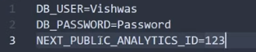

**AUTHENTICATION SECTION!**

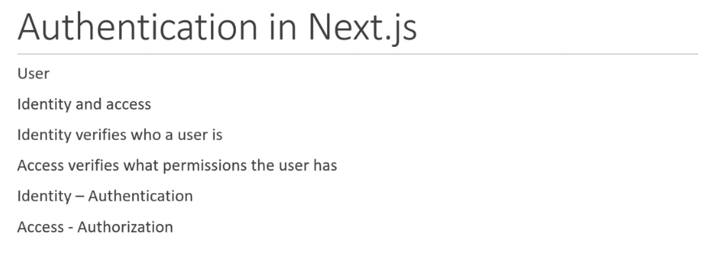

With React the general focus in authentication is on client side. With Next.js there are three areas of focus:

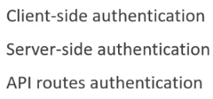

<https://nextjs.org/docs/authentication>

**Next-Auth and GitHub sign-in**

After this you also need to focus on user data. If there is no need to persist the user data then authentication services like google, twitter etc can be sued to ensure a user is authenticated but in our application user data will be required with the use of a database.

NextAuth.js is a library which helps with the creation of authentication within a next.js application and will save a hell of a lot of time in the code writing process.

So we are creating a new next application for authentication called next-auth.

npx create-next-app next-auth.

To walk through this tutorial we are creating a Navbar. We need to create this as a component so we include this in a new components folder and then add it to our _app.js file. We’re using component specific styling in this tutorial (instead of loading in something like bootstrap for example). So we need to import the css. File into our app.js file otherwise it will look like a bullet-point list at the top of the screen… not good. Now we are going to integrate a github authentication. There is a convention that this. Within the api folder inside ‘pages’ we are going to create a new folder called ‘auth’ and in that will be making a catch-all route called […nextaugh].js.

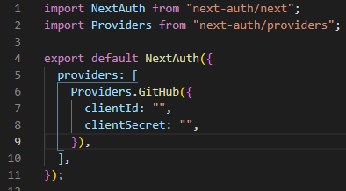

Here we can see the necessary imports we’re going to be using as well as the function itself. We then default export the NextAuth function passing in a configuration object. This object accepts several keys, one of which is ‘providers’ which refers to the services that can be used to sign in a user. This is an array property as there are a number of different services that could be used. In out case it will be an array with only one object which will be:

‘Providers.GutHub({clientId: “”, clientSecret: “”,})’

These are values that are created in the github app.

In github we’ve created a OAuth application in the developer settings.

After doing so we are provided with a Client ID and Client Secrets.

<https://next-auth.js.org/configuration/providers/oauth> for more information on all this.

There are differences it seems between version 3 and 4 of next-auth so the above had to be changed to the following to work:

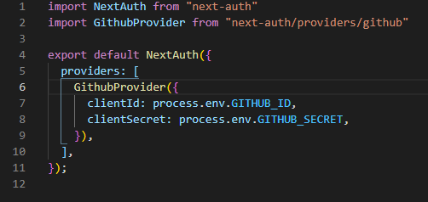

I spent a decent amount of time troubleshooting a problem here because I was getting an error saying that there was no client_id. This was because I had placed the local env file WITHIN the pages folder… It always goes in the ROOT folder. ALWAYS.

After you sign in you can check the cookies in the browser to see if it’s actually worked (though you’ve been redirected to the home page so it should all be good.

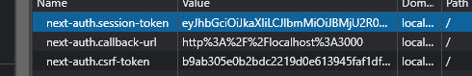

Here’s the next.auth cookie which is created as a result of the signin.

After you sign out the cookie is removed.

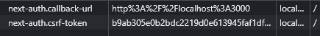

So now we have the api working with a github sign in but we can’t expect the user to type the url in so now lets incorporate this functionality into the NavBar.

In the Navbar component we now need to add some code to our anchor tags for signin and signout. For starters we need to precent the default function of the anchor tag and then we need to run our signin/signout function which we’ve imported from next auth.

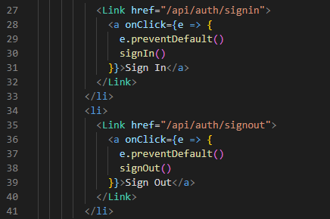

Following the link in the anchor now will take use to the default signin page for github set out in next-auth. Because we’re only using the one authentication provider, GitHub, we can just add this as an argument for our signin function.

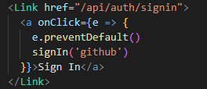

**Client-Side Authentication**

[**https://next-auth.js.org/getting-started/client**](https://next-auth.js.org/getting-started/client)

So here we’re now going to look at the process of showing content to users on the web app based on whether they’re logged in or not.

A good example of this is the sign in and sign out buttons themselves. When you’re signed out you don’t need to have a sigh-out button visible. Similarly when you’re signed in, you shouldn’t see a sign in button.

The next-auth package has a hook specifically for checking whether a user is signed in or not. This is called the useSession hook and will need to be imported along with the signIn and signOut functions from next-auth/react.



So we need to call this hook now within the component. We’re working with the NavBar so this is where we’re calling this hook. It’s not part of the JSX either so it will go before the return statement.

Like with previous hooks we’ve focused on in the React tutorial, we need to destructure this and pull out the values that is returns which are the session object and a loading flag.

Next-Auth has recently undergone an update which makes this slightly more confusing. Firstly in order to make use of the useSession hook the first thing we need to do is wrap our ‘global app’ with the <SessionProvider /> tag.

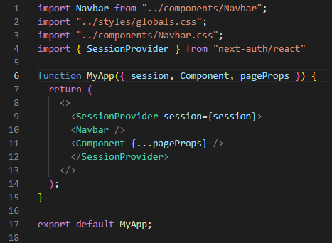

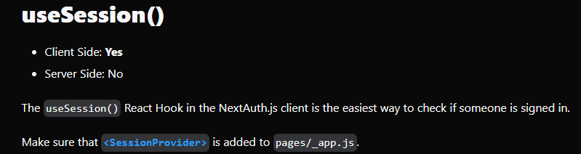

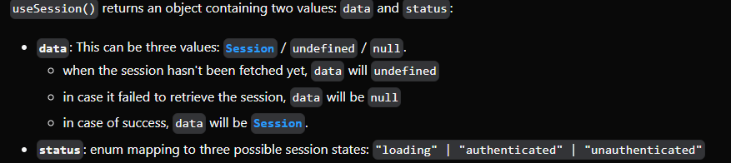

When we load the page we can see that these print statements appear three times.

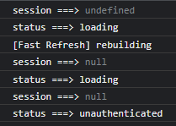

Load 1

In the first load we see that the session is undefined and status is set to loading. Essentially, at this point, next-auth doesn’t know anything so is trying to find out whether the user is logged in or not.

Load 2

Then in the second render, next-auth has worked out that the user is not logged so the session is set to null

Load 3

Finally, next-auth has worked out that there is no logged in user and there is no user authentication so status us set to unauthenticated.

Taking the above into consideration we now have to wrap our signin and signout buttons on our nav bar with some code to check on the nature of our data and status values.

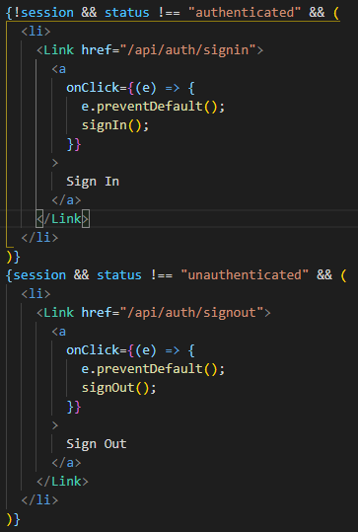

We’ve also added some useful log statements so we can see what’s happening when we refresh and load a page.

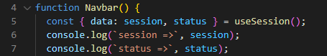

So, when the user first hits a website and is not signed in, we want to display non-specific information relating to the website and give them the option to sign in.

In this case I see no reason why the logic for displaying something if a user is NOT logged in cannot be changed to the following:



Similarly it make sense to change the logic for displaying something if the user IS logged in to:



You can see that when you do sign in, the sign in button does flicker for a very brief time before it disappears. This is to do with the fact that this check is all done client side so the information has to be sent and received from the server before it is read client side and therefore a small delay happens as the previous render changes to the new one. An interesting aesthetic work-around for this would be to create a transitional effect for the component depending on whether it is loading or loaded so that the flicker is hidden by the effect.

In the Navbar.css file we add the following components.

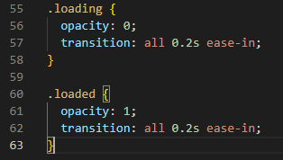

Then we need to update our Navbar.js file and apply these classes onto the ul tag under the className attribute.



If there is no session but the session is loading, then we apply the loading class and if not we apply the loaded class. Here we’re taking advantage of the behaviour with regards to these three loads that occur when the client side renders the page.

Easy….

**Securing Pages Client-Side**

Now we are going to focus on the access to pages dependent on whether a user is logged in client side. We’ll focus on the dashboard page for this one. At the moment the Dashboard page is accessible by clicking the link in the NavBar. Lets modify this so that only users that are signed in can access the dashboard page and if the user is not logged in then they will be redirected to the home page. First lets add the useSession hook to this page so that we can keep tabs on the state of the user.`

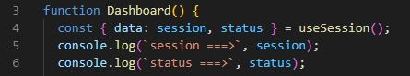

Now we can see when we load the page the following console statements:

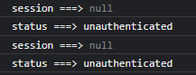

We can latch onto this ‘unauthenticated’ property in the same way we have done with the navbar. 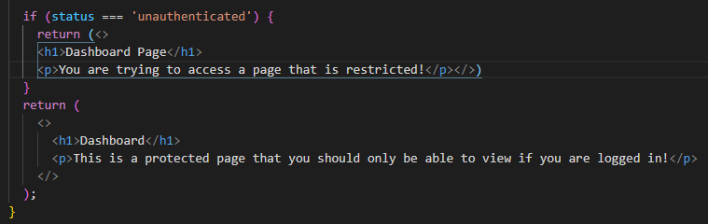

Something like the above would work.

What would be nice though is that instead of a message saying that a page is restricted, we could prompt a user to log in to view this page.

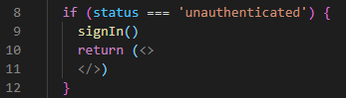

This would work here as well but there is a flash just as there is with the Navbar while next-auth tries to work out whether the user is authenticated or not. We could bypass this with something like a loading screen. The session changes from undefined to the user then we know that a user has logged in so we could use a !session snippet in our code to help out here. What we also need is to keep track of whether the page is loading or not and do display something dependant in that. We can use the useState and useEffect hooks here to our advantage. Firstly we create a state called ‘loading’ and set it to true.

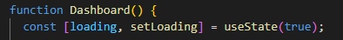

Then we use the effect hook to create a variable that runs a function telling us when to set the state of ‘loading’ from true to false. This part takes advantage of the getSession import.

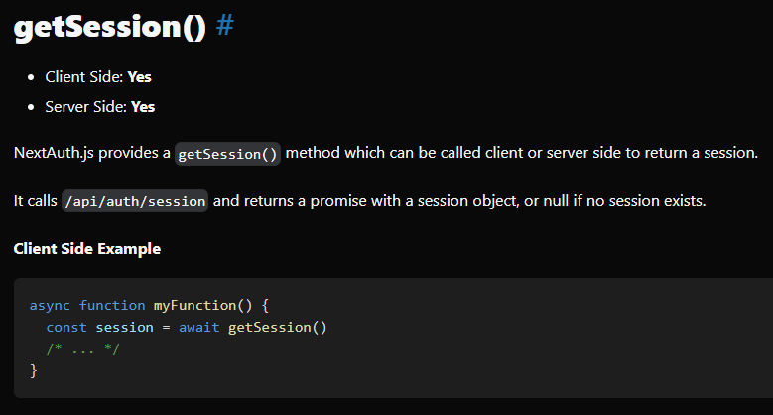

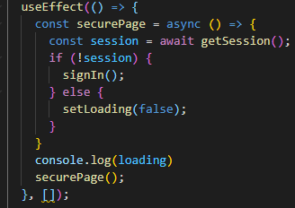

So if our call of getSession returns anything apart from ‘session’ (in other words, null or undefined) then redirect to the signIn() which is a next-auth method. Otherwise setLoading is changed to false.

Then we simply call the function again to loop it till the ‘loading’ state changes. Now we keep an eye on this loading state in the JSX and create an if statement loading different information depending on whether ‘loading’ is true or false.

The final product is below and as you can see from the log statements we can now see the functionality of the useEffect hook and when it breaks out.

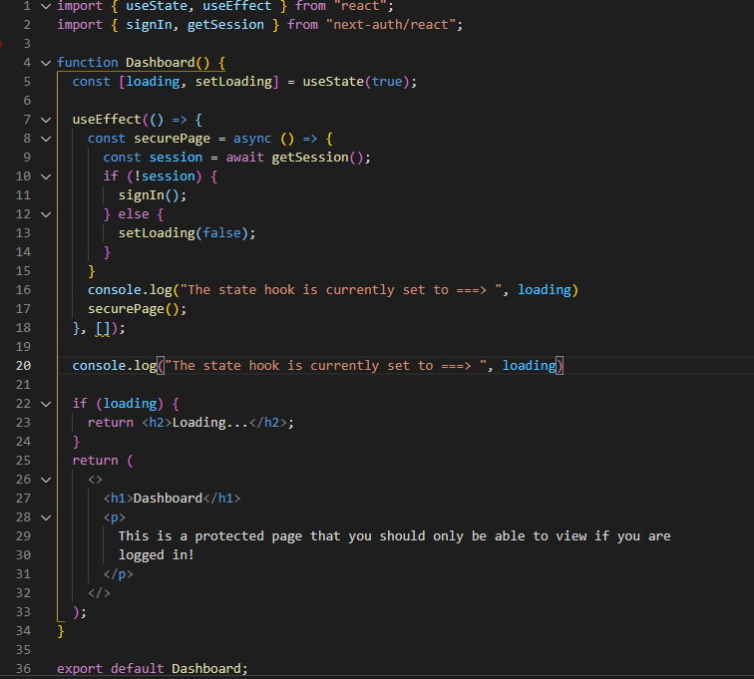

In the browser the console will print out something like this:

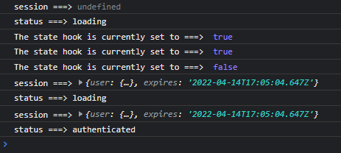

Now, because the dashboard also appears in our navbar we should probably make it unavailable to a user who is not signed in just like we did for the sign in and sign out buttons. The problem is that if we ONLY do this and don’t go through the process we’ve gone through above it will still be possible for someone to get onto the dashboard page WITHOUT logging in by simply typing the correct URL into the browser. WE DON’T WANT THAT.

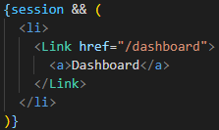

There we go!

**NextAuth Provider**

At the beginning of the ‘Client-side Authentication’ section some of this was briefly covered owing to the recent changes in next-auth. Focusing on the useSession hook, we can now focus on how to share the session state across components. Not just the navbar but over all pages.

As we saw above, in order to make use of the session object throughout your app, you need to head to the top of the tree which in the case of a React app is the _app.js file. In here import the Provider from next-auth and the use it as the outer-most tag for our application:

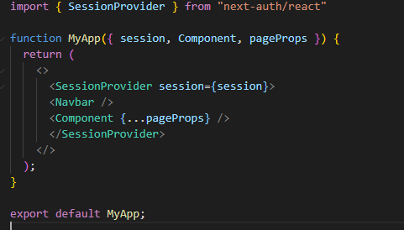

If we head back to our index.js file and import the useSession hook into our function and also log the values of session and status we will see the following:

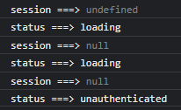

Now there is a clear process as described right at the start of this section. Signing in produces the following log:

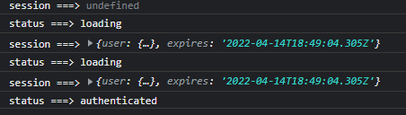

So we can see that the session object is now present and can be used within the JSX to render user information and indeed anything else we want to render based on whether a use is logged in or not.

As an example:



This will render the user’s name in the h1 tag if there is a use logged in or an empty string if not…



This is all possible because the SessionProvider allows instances of useSession to share the session object across components by using React context under the hood. This is the preferred method of keeping tabs on the session object as it improves performance, reduces network calls to get the session and reduces the instances of flickering that we experienced in the loading of the dashboard and of the Navbar earlier. It doesn’t stop this flickering altogether but reduces the number of times the flickering will occur. This is because the after a network call has been made to fetch a session when loading lets say the dashboard page, returning to the home page after will not require another fetch to be made as the SessionProvider will simply hand this fetch over to the useSession hook. A simple way to observe this is in the network tab of the developer tools. Clear the screen and reload the page. Here we can see that a fetch is made for the session object. If you then load up the home page, there will not be a second fetch but the page will still load the user name as coded above. Similarly, the log statements when loading the home page will be as follows:

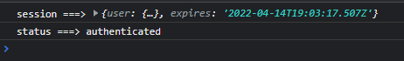

Only the one instance of the useSession hook as the session object is already in play.

All this goes towards speeding up the loading times and improving user experience.

Recommended approach! Use this in the future. As soon as you install the nextauth package, place the SessionProvider in your _app.js file!

**Server-Side Authentication!**

The concept of server-side rendering is similar to that of the client-side. In the previous example we got hold of the current session and used it to determine what to render in the UI - bringing in the user’s name into the title of the page etc. In Server-side rendering, we need to get hold of the current session as well, but after that, instead of determining what UI to render, we determine what props to send from getServerSideProps to the component….

For the example we’ll focus on the blog page which, in this case, we will assume needs to be rendered serverside.

Firstly we note that we’re using getServerSideProps and not getStaticProps. getStaticProps runs AT BUILD TIME where as getServerSideProps runs on every incoming request and contains information about that request. So this function is used to fetch data but before we do this we’re going to have to check whether the user is logged in or not. This is something that we’ve already done above but with a twist. We use the getSession function once again and call it within getServerSideProps. This function returns a promise and as with other promises we need to await this return and assign it to a constant which we will call session. Here is where the twist comes in. In client side rendering we call the getSession() function by assigning it to a constant and waiting for the promise as we did on the dashboard page:

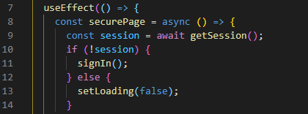

The difference between this and server-side is that in server-side you need to pass in the request information into the getSession() function. Going right back to the rendering section of this tutorial (page 39), we can see that the getServerSideProps function contains a context parameter which is an object that contains a number of keys including params, req and res etc. In our blog function we need to include this async function and its context parameter and then pass this context into the getSession() function.

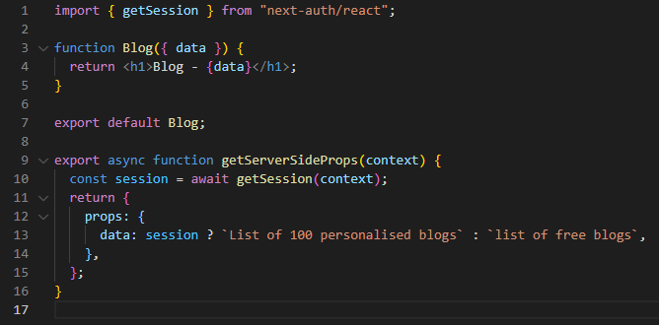

What we’re returning from our server-side rendering is simplified here as a simple string. But you can see how the system would work to pull something from somewhere else - an api for instance. We check first to see if the session exists and if so we load in the ‘list of 100 personalised blogs’ otherwise we load in the list of free blogs. As with the getServerSideProps examples back on page 39, we now need to destructure these props from our async function and render them in the UI.

Job done!

**Securing Pages Server-Side**

Now that we have a blog page that built-in authentication controlling what is displayed, lets get a bit greedy and set it up so that if a user is not logged in then they will be redirected to the sign-in page.

Because we have the session object now being shared throughout the app, we can simply check it to see whether a user is logged in or not. We also include the redirect object in the return statement - see page 66 here for info on redirects. Go to the [redirects section](https://nextjs.org/docs/api-reference/next.config.js/redirects) of the next.js website for more information.

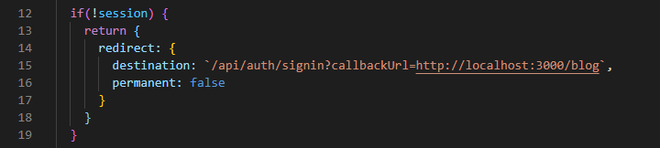

Something important to note here is about the behaviour of the permanent key. We’ve set it to false in this example which implies that this redirect is NOT permanent and that it will only be used IF a user is NOT logged in.

So to summarise, to secure a Server-Side rendered page, you need to include the getSession hook inside the getServerSideProps hook and if the session does NOT exist we return a redirect object with the appropriate destination and set the permanent key to false. Standard practise, by the way, is not to hard code a url in the manner that we have here. Better to create a variable and use it within the url:

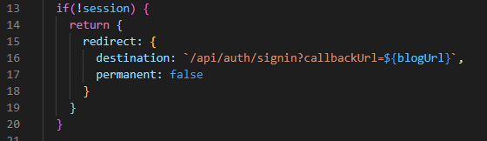

**Securing API Routes**

OK so we have covered securing client and server-side pages using authentication. Now it’s time to secure those API routes as well. Don’t want people attempting to access sections of our website by typing in urls etc. This is very simple - apparently.

So we create an async function which uses the getSession hook to assess whether the user is logged in or not by trying to get hold of the session object. When we call the argument though, instead of using context as the object to call into our getSession function we are requesting here so we have to bring in the req key. Technically you to bring in the key and the key’s value but in this case both are the same so we can shorten it to just ‘req’ (shorthand syntax). Once again this function returns a promise so we have to await it and assign it to a constant which we are calling session (cause that’s what it is!). Now we can create a response based on the value of session being null or the session object.

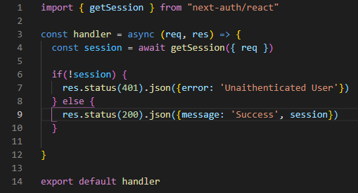

So we return a 401 error if no session and we’re sending back the session object if there is a session. Finally export it!

Done

This is obviously a simple solution and in practical terms you will be presented with requests to grant authorisation to specific users which, now that we’ve grabbed hold of the session object, is quite easy to do. Requests can be handled in different ways as well so the sky’s the limit. Just remember that you need to incorporate the getSession hook (with the SessionProvider wrapped around your application) to ascertain whether the session object is available or not.

**Connecting to a Database!**

In this section we will focus on the process of connecting to a database and persisting the session object during this process. In this example we will approach this using Mongodb - other databases are available.

FYI - Next-auth can be used with any database and there is in-build support for the most popular database types.

The first half of this will be relating to the set-up of MongoDb.



These lines must be added to our .env.local file. The username and password are defined in the network settings on the MongoDB website.

We’ve also changed the connections so that anyone can connect to the cluster - not individual IP addresses.

The URL comes from the website as well

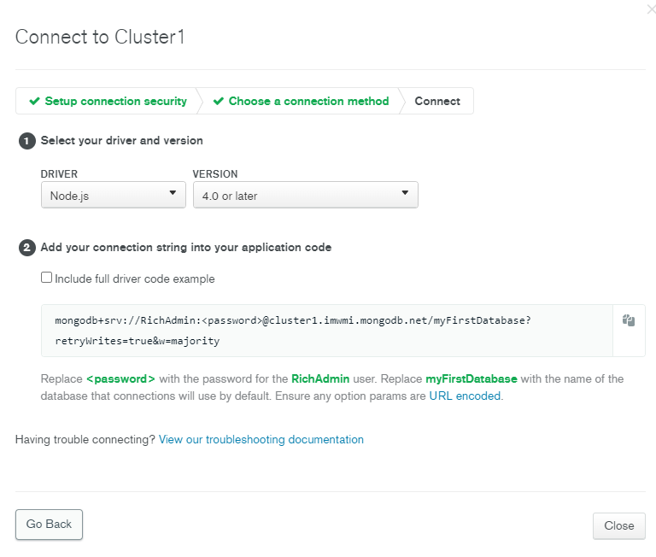

We’ve not only replaced the password, we’ve also replaced the username so that neither are hardcoded into the URL. We’ve also changed the myFirstDatabase to the named database on our cluster in mongidb

This is called testdb.

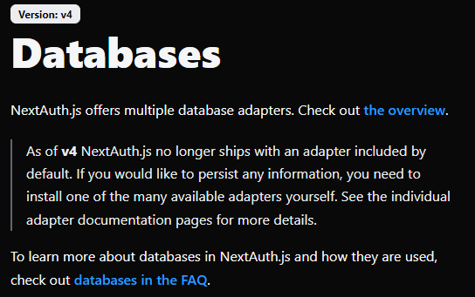

<https://next-auth.js.org/configuration/databases>

So in order to use MongoDB we are going to need to incorporate an adapter.

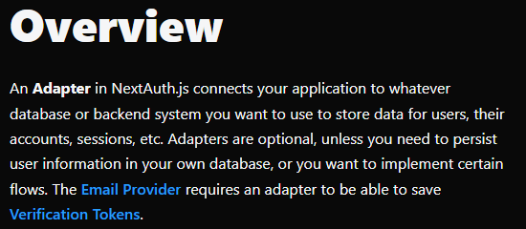

<https://next-auth.js.org/adapters/overview>

I you follow the process dictated on the site then it should work. We’re going to use a configuration object to connect to an email account, not a connection string.

Important thing to note is that if you have not created an actual DB yet then you need to do that first!

Also make sure that you apply all the changes to the url to connect to the db which is change the name, password AND the name of the db.

If it’s worked properly then you should be able to go into the collections section of your database and see that you now have accounts, collections, sessions and users which have propagated with the information that has been sent over from our application when we signed into github!

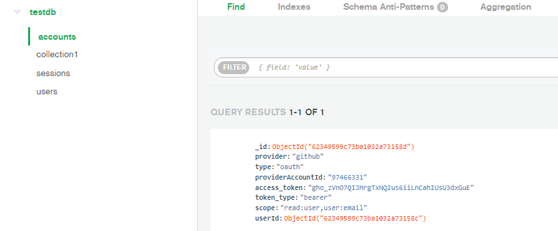

**Callbacks**

Focusing on the session object now:

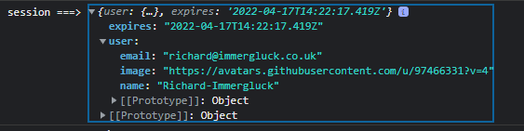

This is taken from the developer console in the browser.

Although these values are specific to the user we cannot use them to identify the logged in user. If you need to perform a CRUD operation that requires user id it would not be possible with the default information that is loaded into the session object. This is where callbacks come into play as you are going to want to add custom properties to the session object.

Here we are going to focus on adding a unique ID field to the session object.

First of all, we want to incorporate JWTs which are JSON Web Tokens. In Next-Auth, these tokens are enabled by default as long as you’ve not specified an adapter already. Now that we have we need to ‘re-enable’ JWTs.

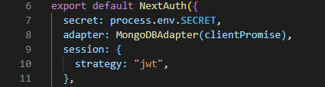

As you can see, it’s included inside the session object inside the NextAuth component. There is a slight change here in the syntax between version 3 and version 4 of NextAuth FYI.

Now that JWTs are back on the table, we need to incorporate the callbacks.

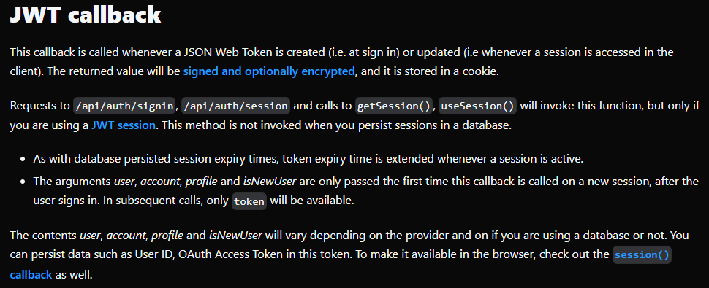

Here’s the blurb about them. So they’re accessed on logging in or when accession the session object.

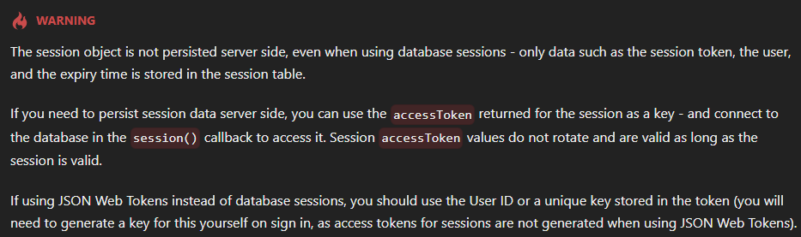

So this is what we’ve done.

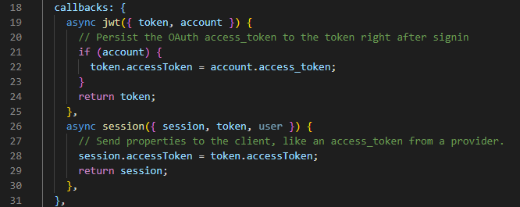

**Deploying a Next.js Application with Vercel**

For starters, Vercel is a platform for deploying web applications that was created by the Next.js team.

Firstly if we want to use verify a user we need to be able to send them an email to verify their email address as most sites do. For this, a common module that is used is Nodemailer.

<https://nodemailer.com/about/>

The documentation states the following:

API - Application Programming Interface

CDN - Content Delivery Network. This refers to a geographically distributed server or group of servers that deliver internet content. This is where the pre-rendered html for a next.js application is stored no loading.

DOM - Document Object Model

Hydration - Filling an object with data. In this case when a react app is loaded and then executes to mount the html elements onto the DOM. This is in relation to react not pre-rendering the html while next.js does.

.json - JavaScript Object Notation.

ISR - Incremental static regeneration. See page 31. Where the revalidate key is added to a getStaticProps function to set a timer on when the relevant .json and .html should be regenerated for a page being served to the browser.

Package Manager: yarn/npm

SEO - Search Engine Optimisation

SSG - Server-Side Generation is a form of pre-rendering where the HTML is generated at request time.

**Conventions**

React file names use Pascal case

PascalFileNameExample.js

Next.js file names seem to use kebab case

this-is-an-exmaple-of-kebab-case.js

Git Lab commits on 20.03.22

